PFAFF corpusclass overview

stchwarz, FUB

2026-01-23 04:17:41.584267

snc:child.doc1.Rmd

knitr::opts_chunk$set(echo = TRUE)  
 #knitr::opts_knit$set(root.dir = normalizePath("/users/guhl/documents/github/dh_essais/pub/hu-lx"))  
#knitr::opts_knit$set(root.dir = normalizePath("/home/runner/work/HU-LX/HU-LX"))  
#print(getwd())  
#cat("----- > docx:",list.files("docx"),"\n")

# index

rmds<-list.files()  
#rmdns<-paste0("site2/src/",rmds)  
rmds

## [1] "__quarto.yml" "_book"   
## [3] "_bookdown.yml" "_output.yml"   
## [5] "_pdf.yml" "a_intro.Rmd"   
## [7] "be1_exmaralda-0.Rmd" "be1_exmaralda-021.Rmd"   
## [9] "be1_exmaralda-022.Rmd" "be1_exmaralda-023.Rmd"   
## [11] "be1_exmaralda-031.Rmd" "be1_exmaralda-041.Rmd"   
## [13] "c_audacity.Rmd" "c_sesdb01.Rmd"   
## [15] "d_sesdb002.Rmd" "direct-store.lua"   
## [17] "e_sesdb003.Rmd" "g_pageske0.Rmd"   
## [19] "h_page001.Rmd" "i_page003.Rmd"   
## [21] "index.Rmd" "j_page004.Rmd"   
## [23] "k_page005.Rmd" "l_annis01.Rmd"   
## [25] "m_berlangdev01.Rmd" "n_ses-status.Rmd"   
## [27] "o_findings00.Rmd" "p_findings01.Rmd"   
## [29] "packages.bib" "pfaff_corpusclass-overview.log"  
## [31] "pfaff_corpusclass-overview.Rmd" "q_findings02.Rmd"   
## [33] "r_findings03.Rmd" "r_findings04.Rmd"   
## [35] "style.css" "t_sesdist001.Rmd"   
## [37] "z1_annex.Rmd"

## meta

version: 20240518(07.53) authored: st. schwarz, FUB

## content

* EXMARALDA
* audacity: how to anonymise interview audio
* explanations to the SES database
* SketchEngine import corpus
* ANNIS framework
* BERLANGDEV workflow
* BERLANGDEV media status
* class findings

## info:

please find [here](https://esteeschwarz.github.io/HU-LX/pfaff_corpusclass-overview.docx) a .docx / pdf version of the pages.  
**mdbook instance:** you can also use the <print> button on the top right side to generate an uptodate printed version.  
to make sure you are viewing the most recent version of the wrap up, reload the pages by visiting: <https://pinghook.dh-index.org?page=pfaff-corpusclass-overview>

for trouble with technical terms/expressions used please consult the [glossary](glossaryannex-on-a-funny-note.html#to-avoid-further-confusion) at the end.

# EXMARALDA workflow

## general

* info/download: [EXMARALDA Partitur Editor](https://exmaralda.org/de/partitur-editor-de/)
* assuming you have successfully installed exmaralda on your system here follow some instructions on how to work with it.
* you cannot open the .exb (exmaralda format) directly from the HU box, you have to download and open the files in the partitureditor.

## transcription: from scratch in template

note: this method is demanding fewer technical skills, but takes longer to transcribe = type the text. if you decide to do use a more technical demanding method, which allows for easy and fast transkription, skip to [section 3.3](exmaralda-workflow.html#transcription-by-merge-imported-text-and-template).

### preliminary

* open the original .pdf you want to transcribe and the partitur editor. best is to have a parallel view of the .pdf and the partitur in horizontal split
* open the template <LLDM_exmaralda_basictemplate.exb> which you download from the HU box or [here](https://github.com/esteeschwarz/HU-LX/blob/main/trans/LLDM_exmaralda_basictemplate.exb).
* in this template you have already the necessary tiers for the transkription and annotation created. (without content)

### speakertable

* edit the speakertable to relabel the tiers:

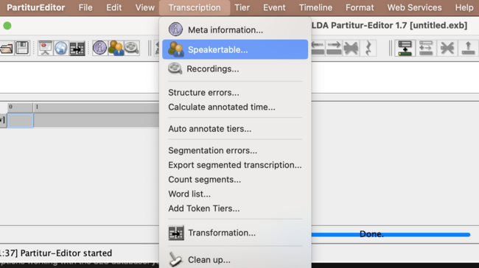

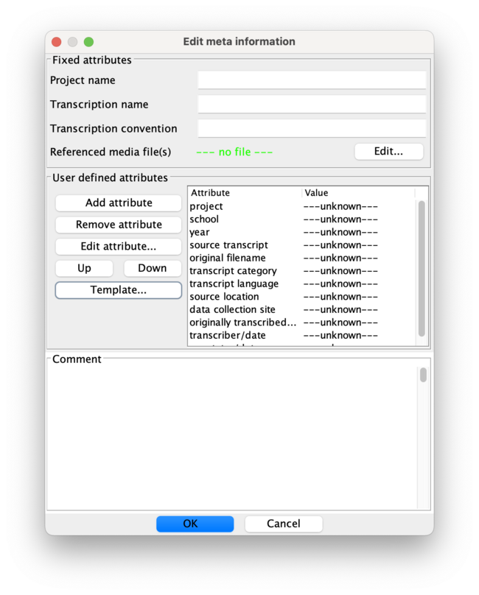

* here you insert the speaker abbreviation as label from the .pdf (e.g. MIM), the language used in the transcript and the L1/L2 if named in the questionaire.
* then fill in the values of the template attributes for the speaker with the corresponding values of the transcript (from the questionaire)
  + left is the attribute name, right the value which is to adapt

### metadata

* edit the transcript metadata:

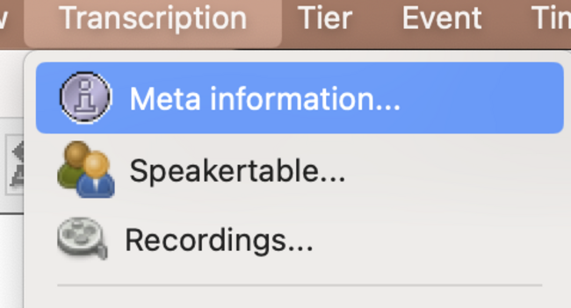



* like above fill in the values of the template attributes for the metadata with the corresponding values of the transcript (from the questionaire)
  + left is the attribute name, right the value which is to adapt

### transcribe the text from the .pdf:

* click into a segment
* type the text
  + at the end of one unit (which is still to define: either sentence, word or syntactic unit) insert a <space:leerzeichen:whitespace> to signal the chat processor, that this is a segment. when you done with one segment and the end of available empty segments of the transcription tier is reached, one new segment is opened when you hit <return:enter> and you can type in the next unit.
  + precisely: for text tokenised per word the steps will be:
    - type word > type whitespace > hit return
      * note: in each after these steps automatically opened new segment you have to type the first character twice, since the input is possible only when you started typing. you will see what is meant by trying…
    - repeat for every word (AND punctuation mark!)

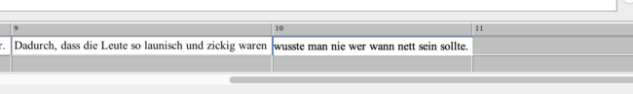

if you need to insert an empty segment in the middle of the transcript (because you forgot to transcribe a word e.g.) you can split an event which creates an empty segment.

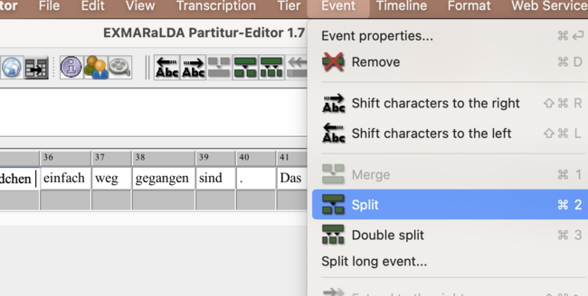

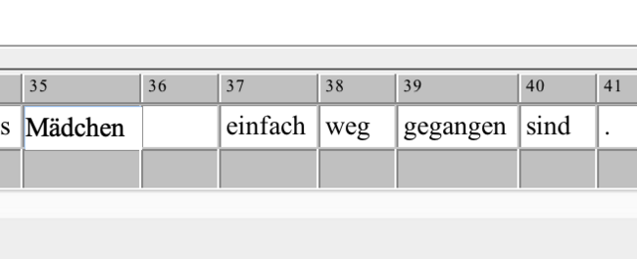

you can also write the whole sentence into on segment an then split like above the segments where you want by positioning your cursor at the right position. the new segment will be created exactly where your cursor is, that would be after the whitespace between 2 words if you place it there. if there was a word after the whitespace, then that would be the content of the next segment (including every word which followed, you have to repeat the step for each word in the sentence.)  
the reverse operation (combining segments) is also possible; mark the segments you want to combine (like cells in an excel table, not with SHIFT-hold, but by moving over them mouse-clicked) and choose <event:merge>.

* save your transcription, it will be saved as .exb

## transcription: by merge imported text and template

note: for this method some technical skills are needed, but you definitely save effort transcribing.

### preliminary

* open the original .pdf you want to transcribe and a simple text editor, rather not word, use [this one (VS Code)](https://code.visualstudio.com) for example.
* best is to have a parallel view of the .pdf and the editor in horizontal split
* download the template <LLDM_exmaralda_basictemplate.exb> from the HU box or [here](https://github.com/esteeschwarz/HU-LX/blob/main/trans/LLDM_exmaralda_basictemplate.exb)

### transcription

* transcribe (type) the text as is is written in the .pdf into a plain text file in the editor
* transcribe *every* written form, including stroke through words or phrases, i.e. every information that could be later on analysed
  + you can mark up information like this or use your own (consistent!) system, important is, that you later be able to transfer your marked up information into an annotation in the transcript, e.g. like here where “an” was stroke through in the original text:

gut erinnern an die Zeit in der Grundschule und _an-strike_ die ersten Jahre auf dem Gymnasium, in der immer viel abgeschrieben wurde

* you can type the whole text in one paragraph, include punctuation etc., be careful transcribing whitespaces, there mustnt be double-whitespaces, be sure of that.
* save the file as .txt

### import text to EXMARaLDA

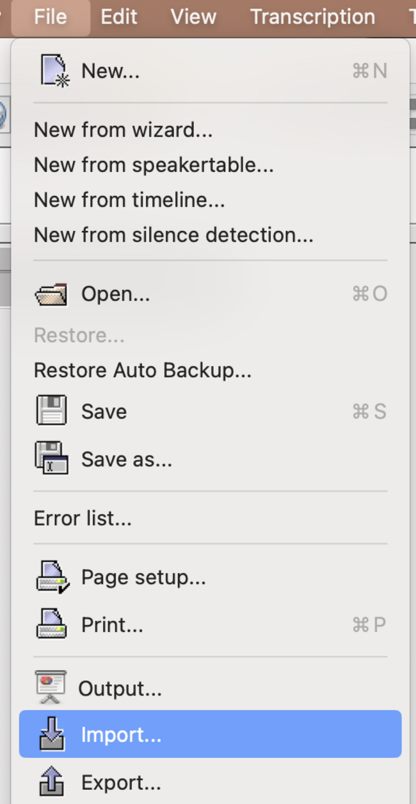

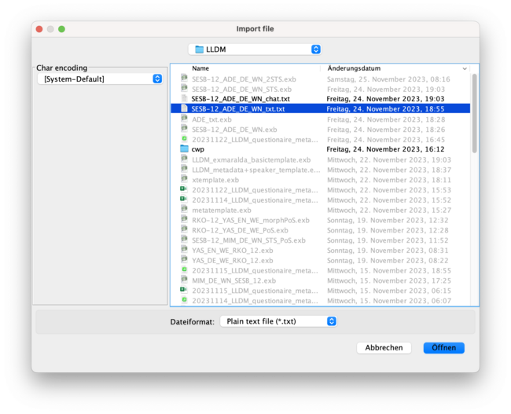

* you have your plain text to be split into segments, which will be one segment / word or punctuation mark.
* for that you choose: <split at regular expression> with the following input (regex formula) (which is very important to be exactly copied into the field:

( |([,.;:!?()] )|[a-zäöüß](?=([,.;:?!()] )))

* in the square brackets (left and right) you see all the punctuation signs after and before which a new segment should be created.
* NOTE: if you discovered (transcribed) more of these, you should put them into the brackets to the left and right (1st and 3rd bracket), not in the middle one.

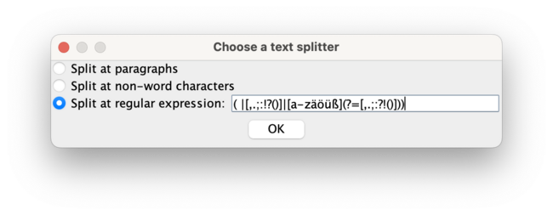

* you should now have a partitur with one transcription line containing your text tokenized
* save that transcript, its just a temporary step

### merge with basic template

* first, remove the speaker:



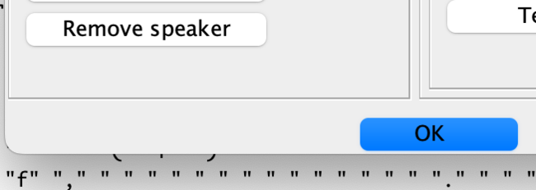

* merge:

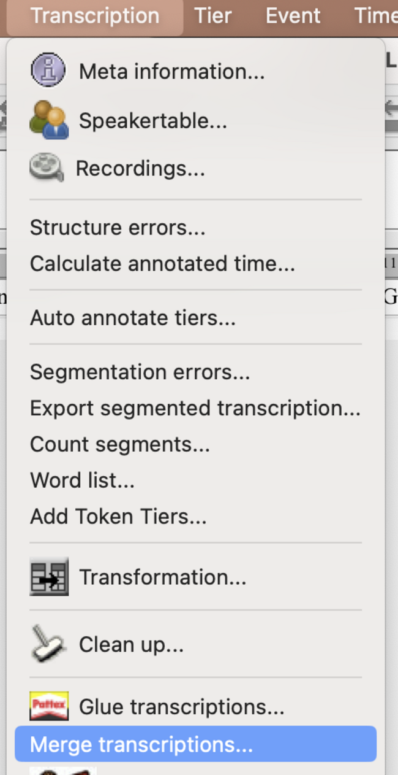

* you have to choose the <LLDM_exmaralda_basictemplate.exb> and double click on it, if it then appears in the box below, you can click <merge>. this will combine the tiers of both your transcription and the basic template.

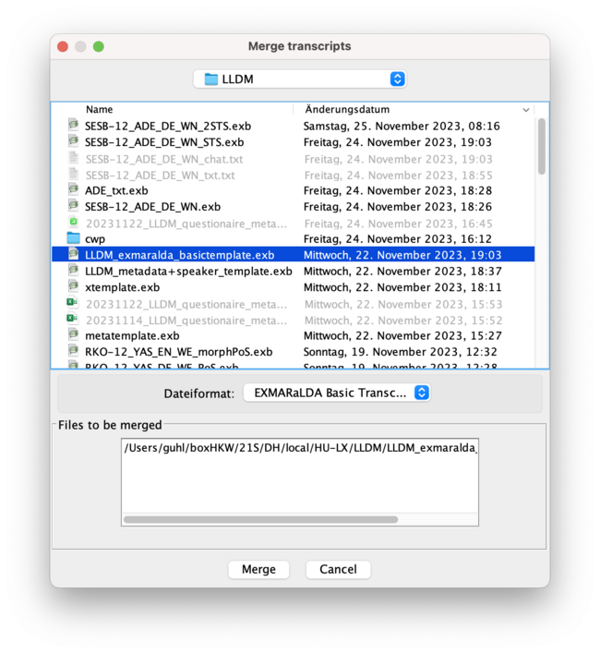

* now there should be a partitur with all 6 tiers from the basic transcript plus your transcription
* clean up the transcription and remove the time labels as follows

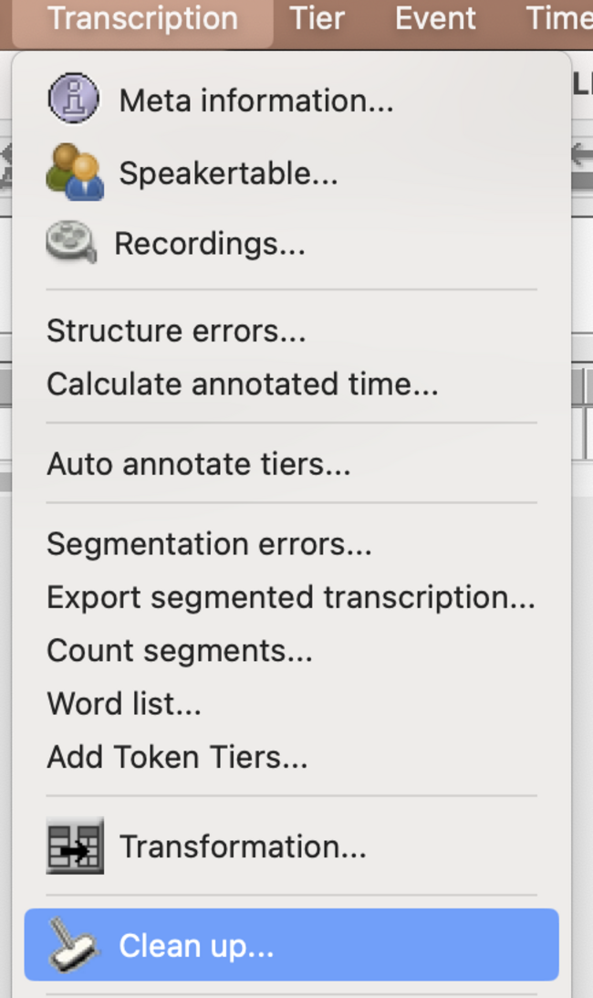

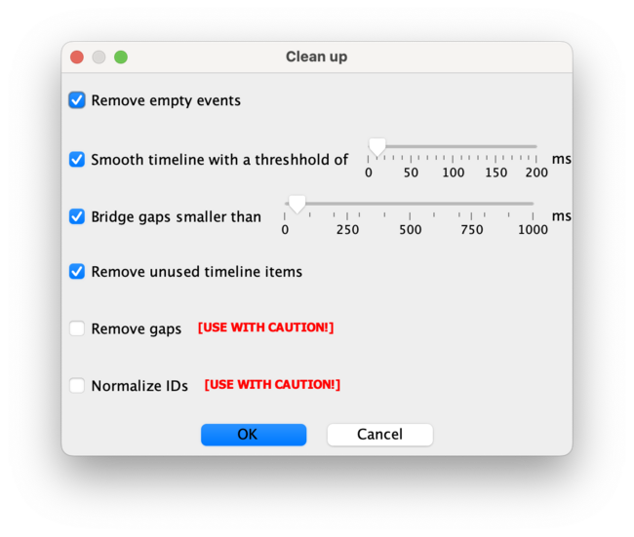

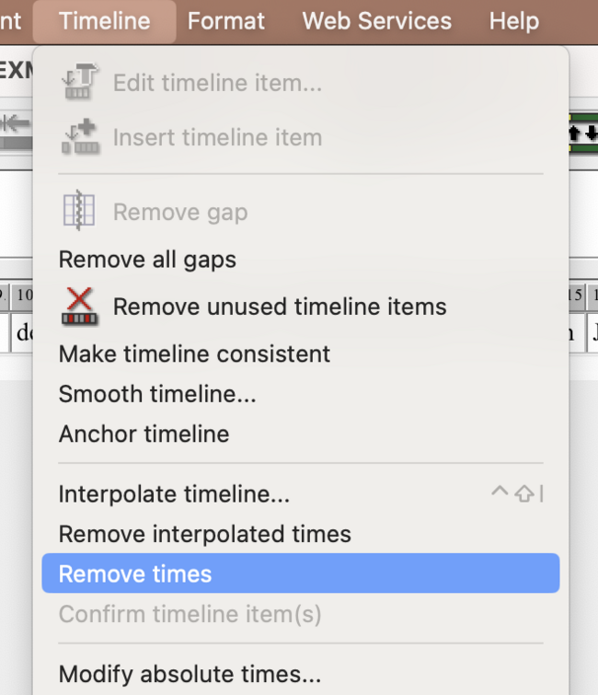

### speakertable

* edit the speakertable to relabel the tiers:



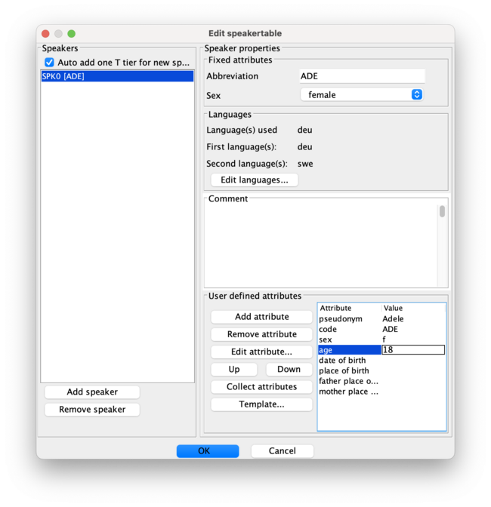

* here you insert the speaker abbreviation as label from the .pdf (e.g. MIM), the language used in the transcript and the L1/L2 if named in the questionaire.
* then fill in the values of the template attributes for the speaker with the corresponding values of the transcript (from the questionaire)
  + left is the attribute name, right the value which is to adapt
* if all works well, the partitur should now display tiers labeled with your participant + the category like

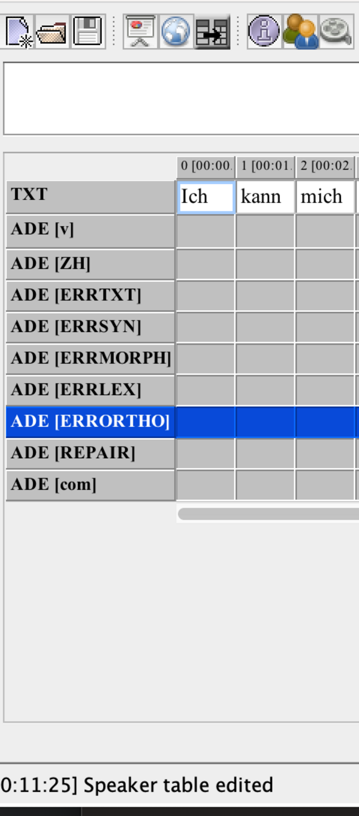

* remove the obsolete [v] tier which is redundant of the basic template.

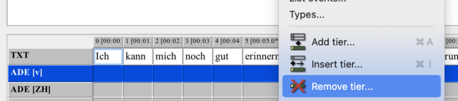

* instead, assign the correct speaker to your <TXT> tier:

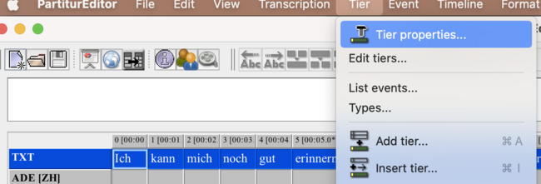

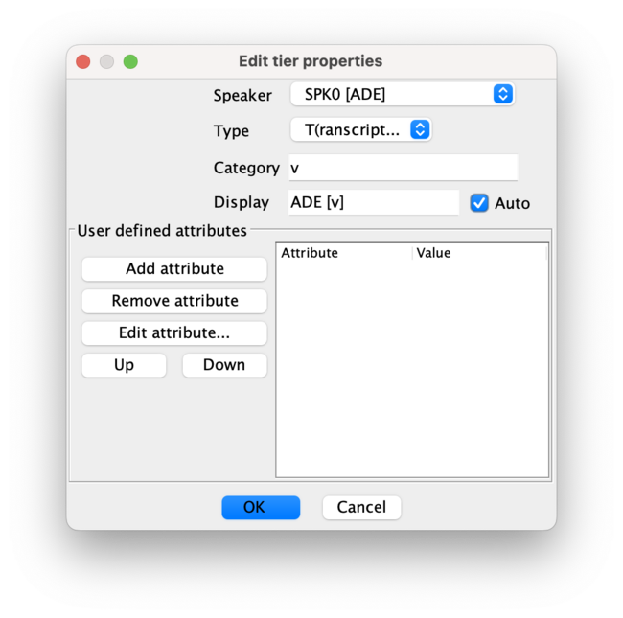

### metadata

* edit the transcript metadata:



* choose <template> and open the LLDM_basictemplate

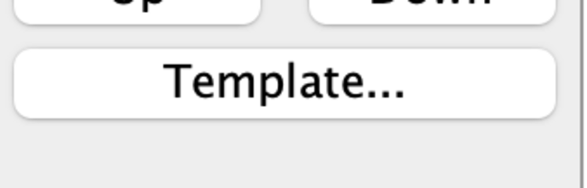

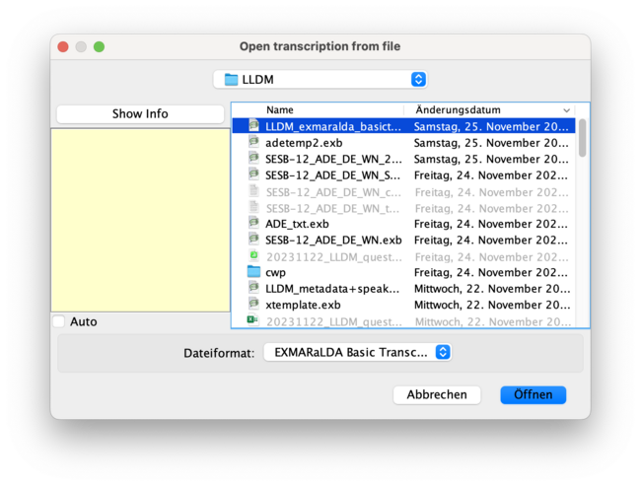



* like above replace the values of the template attributes for the metadata with the corresponding values of the transcript (from the questionaire)
  + left is the attribute name, right the value which is to adapt
* add project name and transcription name according to scheme

#### fin

print("voila:")  
print("dont forget to save your work!")

## transcription: from audio

### preliminary

** this workflow is for simplifying reasons not representative for the regular exmaralda audio transcription pipeline where you would import and navigate your audio directly in exmaralda for CHAT or similar segmentation according to official transcription conventions. keep that in mind if you want to transfer the following process to another project (not the CWP class) where these conventions have to be followed.**

* download the audio you want to transcribe from the box
* **NOTE:** generally the audio has to be anonymised in another step, see [sec. 6](how-to-anonymisecombine-audios-using-audacity.html)
* open the audio preferably in audacity, but you can use any player that plays .mp3 files and enables you to navigate conveniently in the timeline of the audio
* open a simple plain text editor, word is also possible, you have to save the file in plain .txt format (UTF-8 encoded) at the end.

### transcription

* transcribe everything that you hear exactly as you hear it. that means, you *can* interprete what you hear if something is unclear, *but* you should **NO WAY** correct for errors of the participant you perceive.
* that is: you transcribe any style, grammar etc. errors *as* you perceive them and annotate these within the transcript. use a consistent markup that allows you to later transfer you annotations to an exmaralda error annotation tier. you could do it like this:

excerpt:

aber man sollte mit#nonstandard# Personen nach dem Charakter beurteilen und wenn man das nicht macht, dann bist du auf den#nonstandard case# falschen Weg und dann bekommst du auch die (...) nicht guten#style# Freunde

* pauses are transcribed as (…) for longer and (.) for very short micropauses
  + be sure that you type **three dots** and not use the automatically condensed three dots of word. (i really disencourage you to using word, for 1000 other reasons. use [this one (VS Code)](https://code.visualstudio.com) for example or any other simple text editor for your system.)
* save the transcription according to the scheme, e.g. SESB-12_VED_DE_ON_PAB_20240110.txt

### import to exmaralda

* open the partitur editor
* choose <file><new> to create a new document
* copy the content of your transcription (the copied text should not contain anything but the transcribed text + error annotation, no meta information) in one step. i.e. you should have the complete transcribed text in the clipboard now
* paste the text into the segment labeled <1>
* **important:** save the transcription now according to the scheme

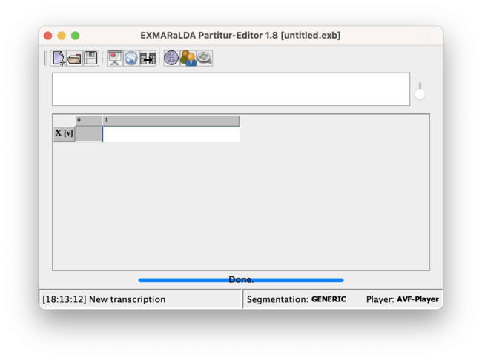

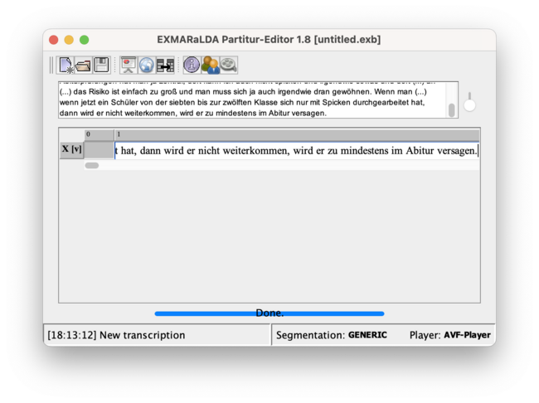

### tokenisation, pos-tagging, lemmatization

* open the weblicht interface of exmaralda

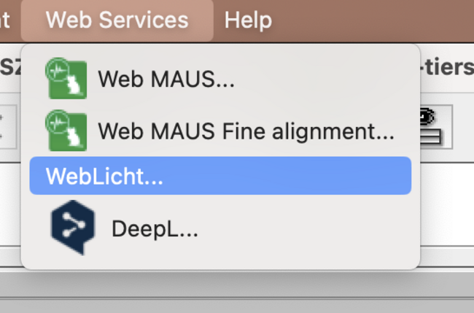

* get you an API key from the website to fill in the key

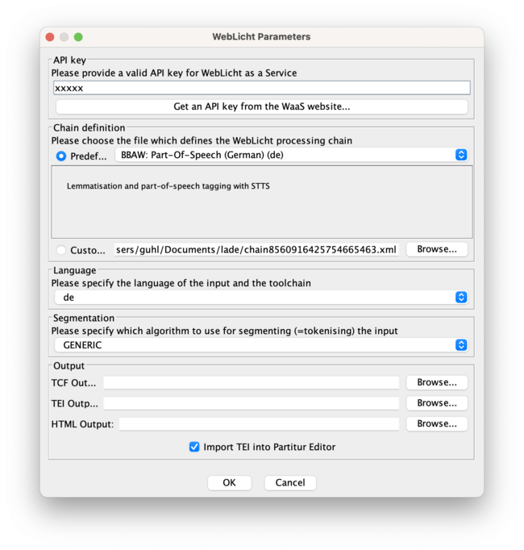

* if something goes wrong, try to clean up the transcription with <transcription><clean up> before applying the weblicht tool. that will remove any unused segments.

if everything works well the transcription should now include a lemma and pos-tag tier.

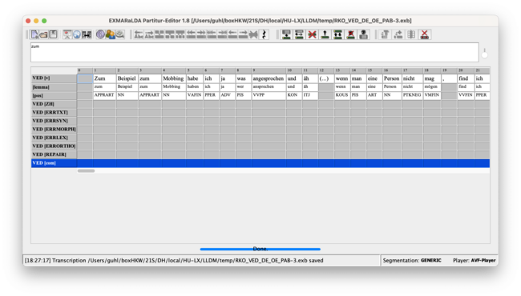

### merge with basic template and edit metadata

follow the steps in [section 3.3](exmaralda-workflowtranscription-by-merge-imported-text-and-template.html) to get the annotation tiers and metadata scheme into your transcription and to edit the metadata/speakertable and assign the speakers.

# EXMARALDA export

## how to export .exb (EXMARALDA-files) to .txt CHAT format

* open .exb file in partitur editor
  + this is only relevant if you dont have the exported file (with which you work in the moment and that you want to export) opened in exmaralda.
* open the export dialogue:
  + *<file>:<export>*
* choose HIAT segmentation
  + if you have the transcript segmented per token (word)
    - e.g. the transcripts for YAS are segmented per token, so choosing CHAT-segmention as export option would put each token in a single line in the textfile.
  + to have a convenient reading view with, choosing the HIAT segmentation export disables the segmentation in this case.
    - for this to work, there has to be a full-stop (.) or whitespace at the end of each sequence to segment the output into sentence lines
* choose a location in your filesystem
* choose *<dateiformat>:<CHAT>*
* name the file with a .txt extension (to conveniently open it in a texteditor
  + this is not obligatory, you could also save it with the .cha (CHAT) file extension since the document structure is CHAT format, it doesnt matter, you can open .cha files in a texteditor also…)

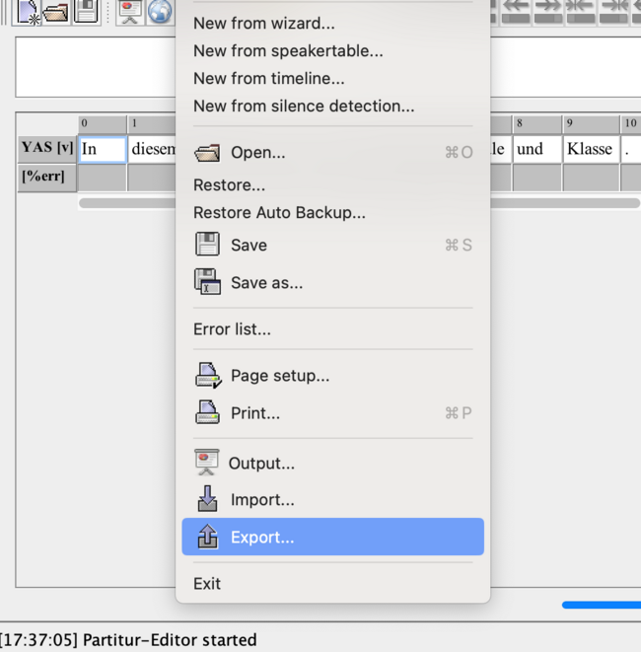

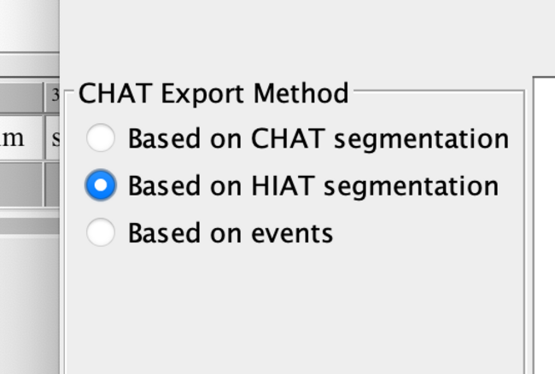

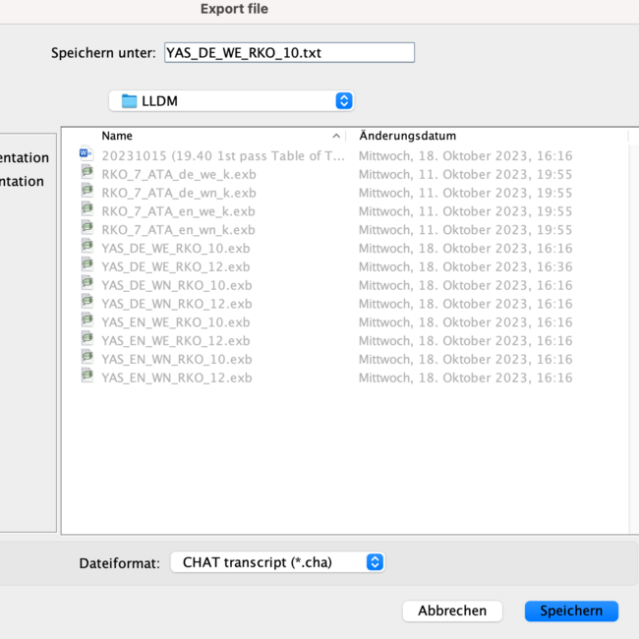

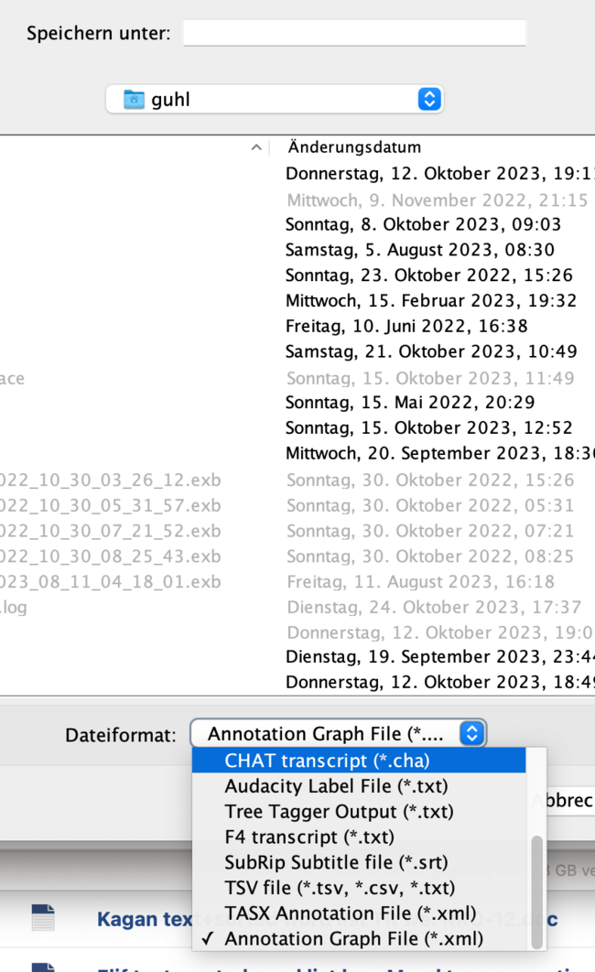

#### the 2 versions view:

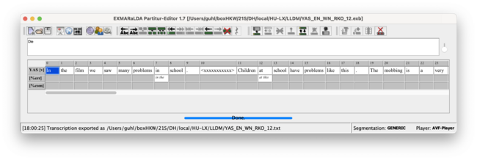

partitur editor view of .exb file

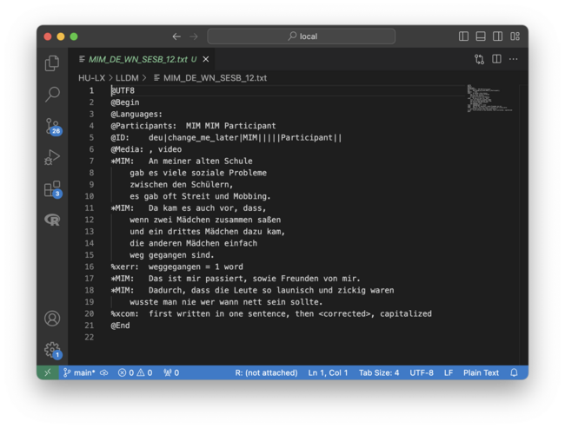

texteditor view of CHAT file

# EXMARALDA coding

#### how to annotate the transcript

## normalisation

if you have finished transcribing the primary text, it is necessary to add further tiers (rows) for annotation.  
you will first add a tier, with a normalised version of the text as content. for that:

* add a new tier
* choose to <copy events from> the speaker tier and label it [norm]

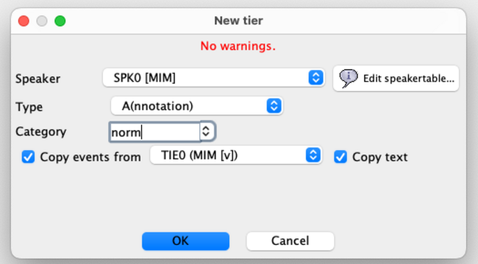

* now you have a copy of the speakerline called X [norm] with the same text as in your transcription tier.
* *normalisation* in this context means that you correct the text in that tier for
  + spelling (orthographic) errors (exluding interpunctuation mistakes)
  + your personal markup of e.g. strike through and other annotations to the text you made in the process of transcribing
    - you should here (in the normalisation tier) remove anything from the text which is *not* text of the participant.
    - use the X[com] (comment) tier to transfer what you observed or, if you already annoted under linguistic aspects, use the [ERR.xxx] tiers and write down you observations
* the [norm] tier is necessary in the next step, where you pos-tag and lemmatize the tokens. to be able to do this automatically, all tokens have to be lexical items i.e. without any spelling errors or markup to enable the algorithm tag them correctly

## pos-tag / lemmatize

* use the WebLicht interface of exmaralda
* get an API key, find the link via the menu dialogue
  + you have to provide your institutional affiliation to get that key
  + copy/paste the key into the field in the dialogue
* choose the german or english pos-tagger/ morph tagger and the language of the speaker text
* **to preserve ERR tiers after postagging there has to be at least one entry in the tier, else empty tiers will be deleted in the process of tagging**

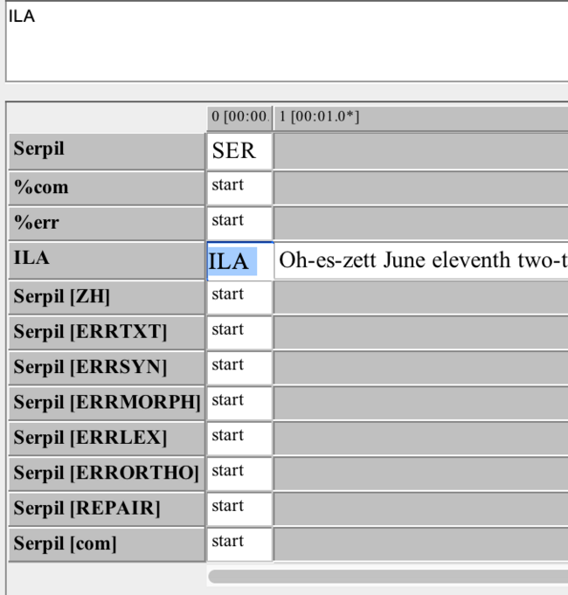



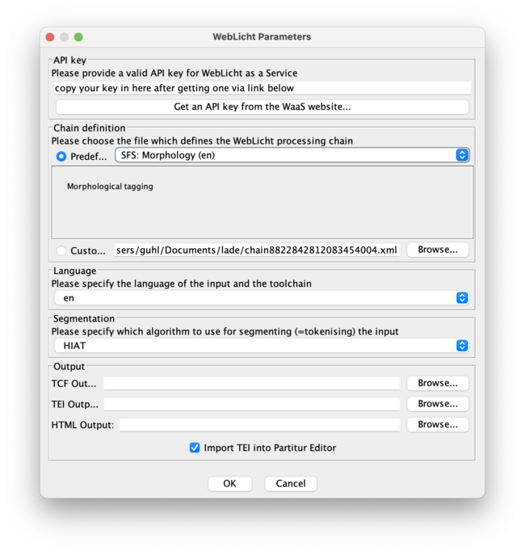

## formulate the ZH

**follows**

# how to anonymise/combine audios using audacity

#### prerequisites

* download and install [audacity](https://audacityteam.org)
* if you will using headphones to listen, make sure to FIRST plug in the headphones and THEN start audacity. that will enable your core audio to use the headphones as standard output.

## anonymise

* first download audiofiles to anonymize from the HU box. folder: [SES audio cut/renamed](https://box.hu-berlin.de/smart-link/04099902-f842-4a14-985c-5e9ec29d917a/). note: the file will probably (depending on your operating system) pop up/open automatically in your default media player application after download. close that application.
* in audacity import audio from downloads folder:
* *[datei] > [öffnen] > datei in downloads auswählen > [öffnen]*

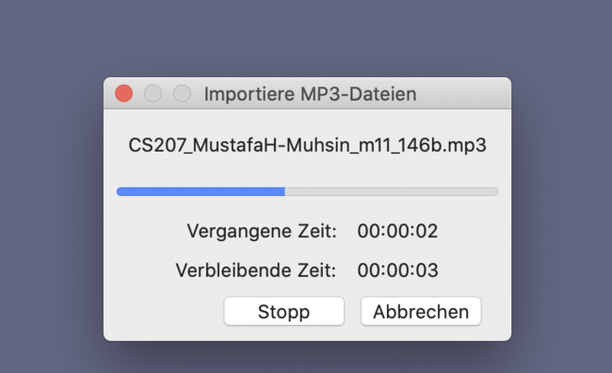

* listen to the audio and find occurences of clear names
* the example here shows the workflow for two instances
* generally zoom in before *[play]*to be able to follow the moving cursor position.
* if you want to stop playing, hit the [pause] button instead of the [stop] button. that will prevent the cursor from returning to 0-position.

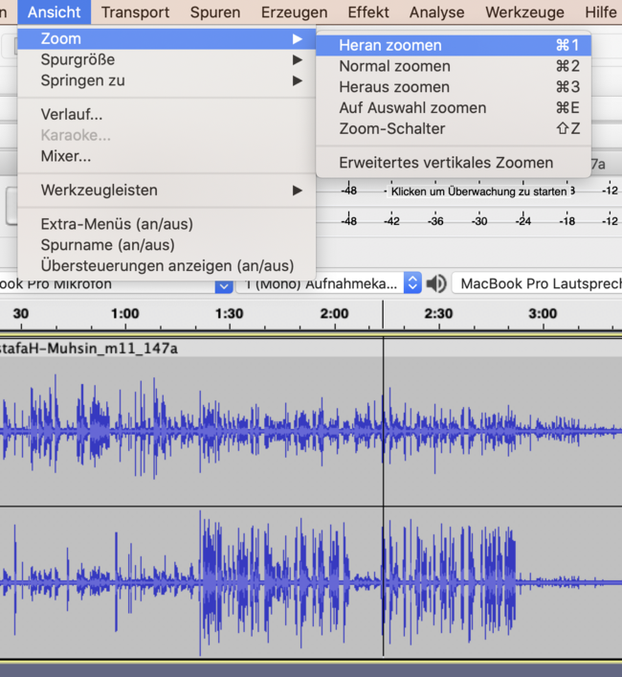

* e.g first instance at roughly 0:09
* ausschnitt vergröszern to specify location:
* mark location with pointer (*click > move right > release click*)
* *[ansicht] > [zoom] > [heranzoomen] [cmd+1]*



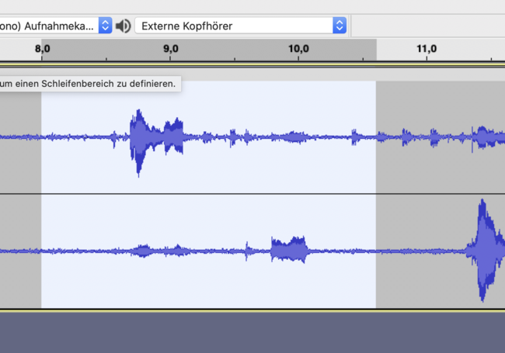

the white field shows the selected (markierte) range in the audio

* repeat/narrow mark location with pointer (*click > move right > release click*)

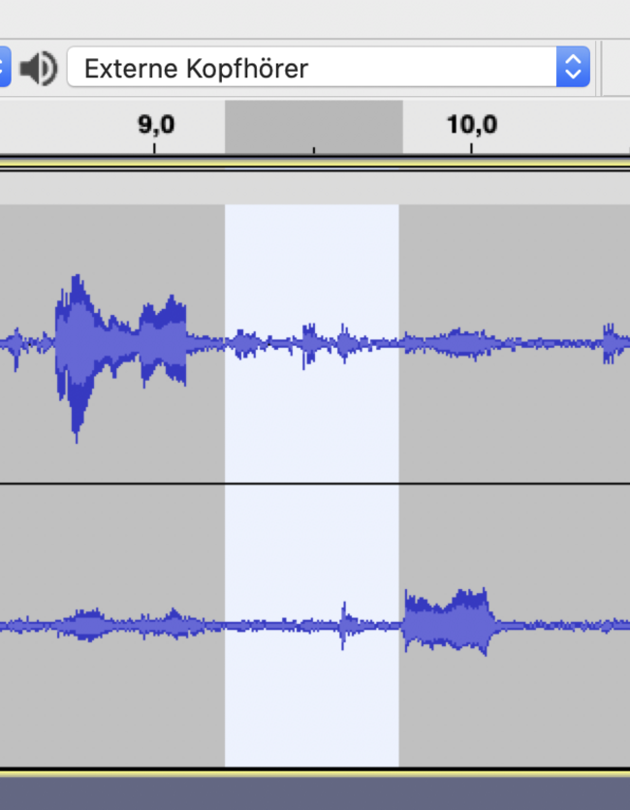

* insert BEEP sound over location:
* *[erzeugen] > [klang]*

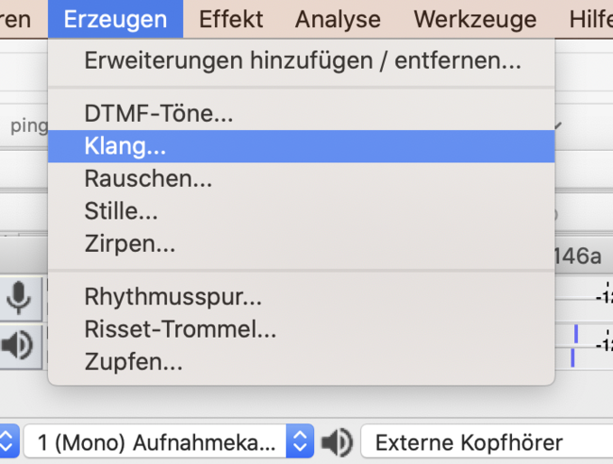

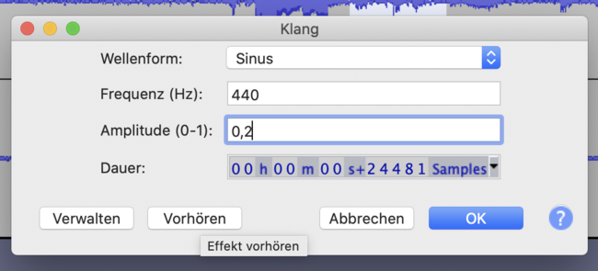

* change amplitude dB to 0,2

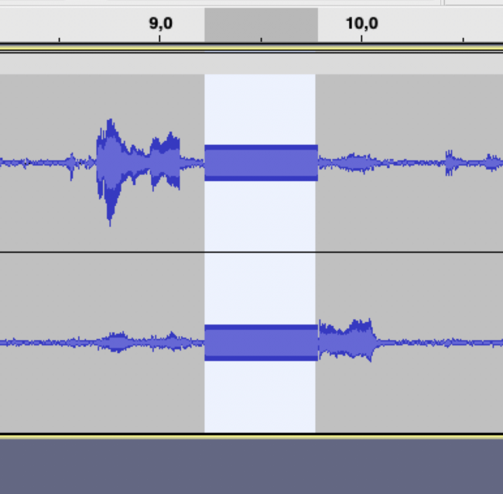

* voila. first sinuscurve inserted.
* repeat for every instance.
* second instance at 11:53
* zoom in

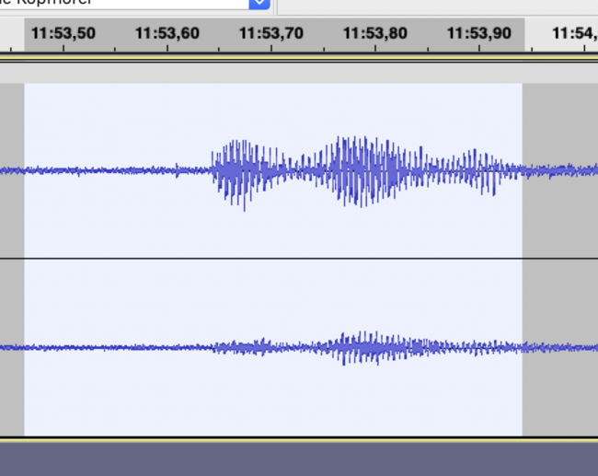

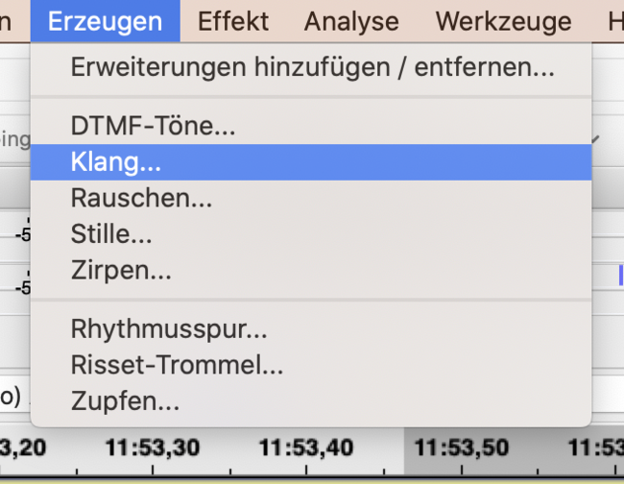

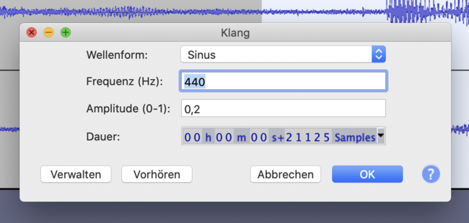

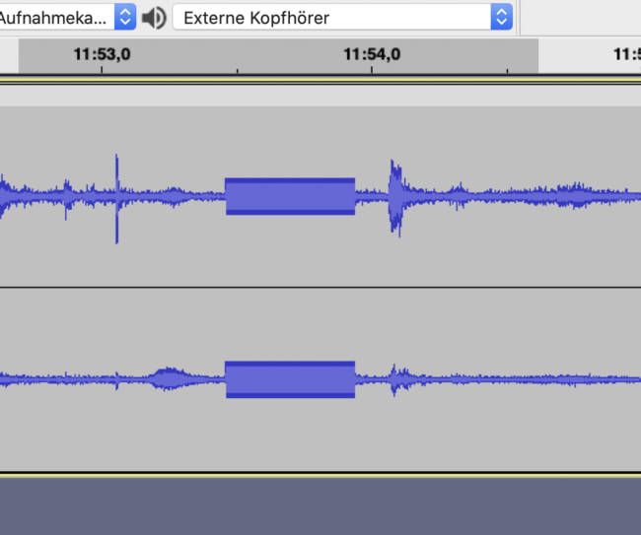

## combine

* how to copy content of 2nd & 3rd audio after end of 1st

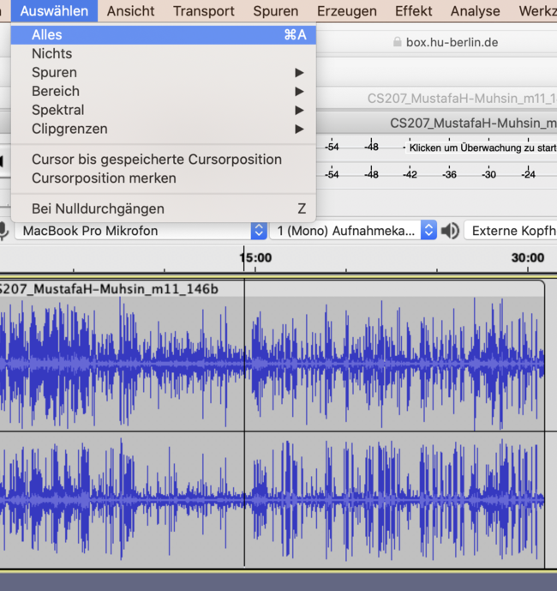

* click into wave of 2nd audio
* select complete wave:
* *[auswählen] > [alles] [cmd-A]*

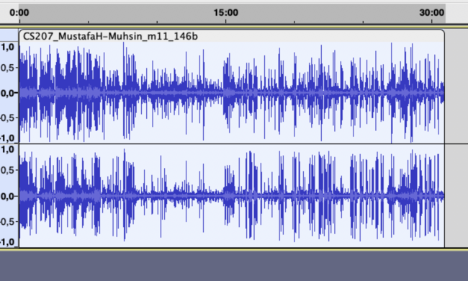

* copy selected wave
* *[bearbeiten] > [kopieren] [cmd-C]*

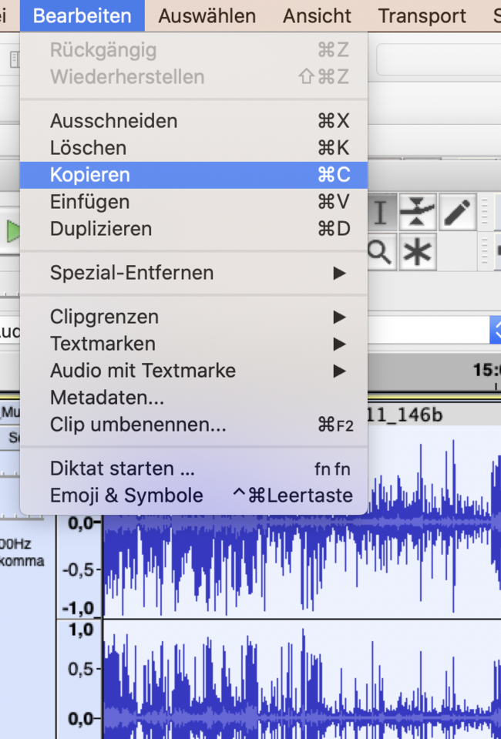

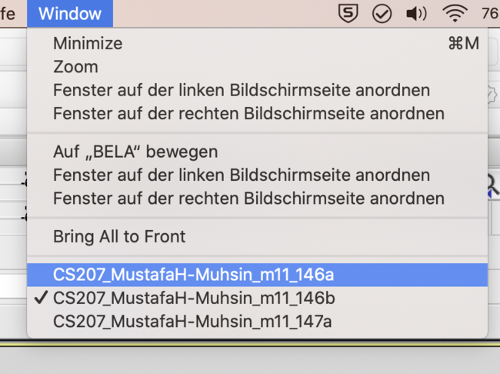

* now change to wave of 1st audio

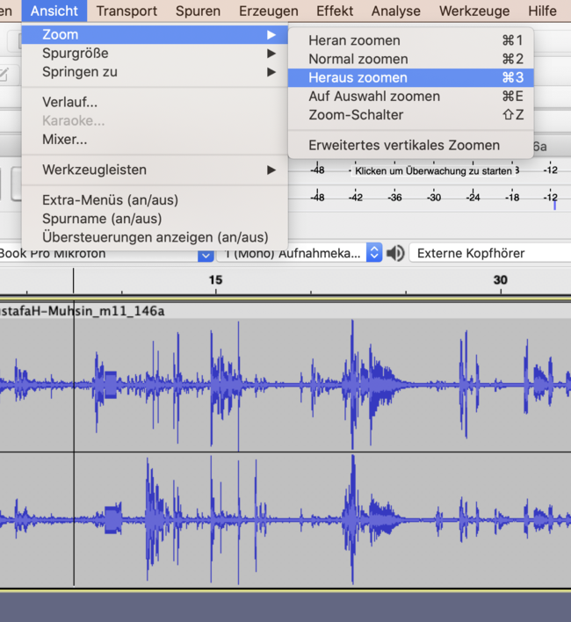

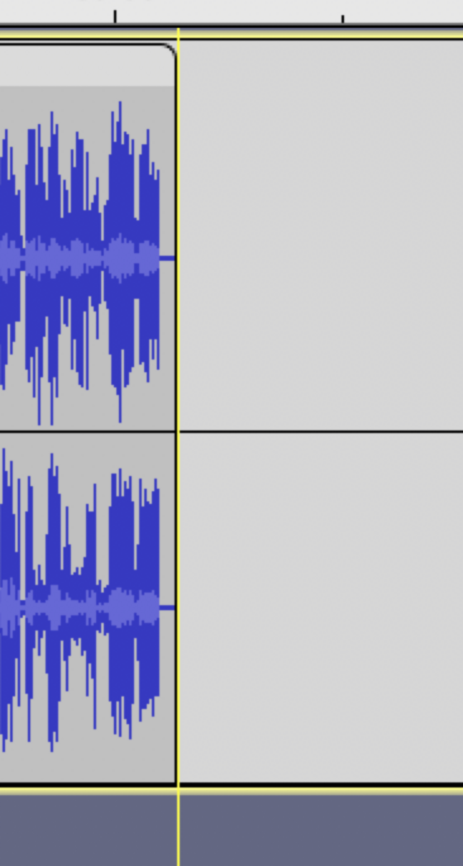

* hover cursor over end of the track
* click. should appear one yellow line

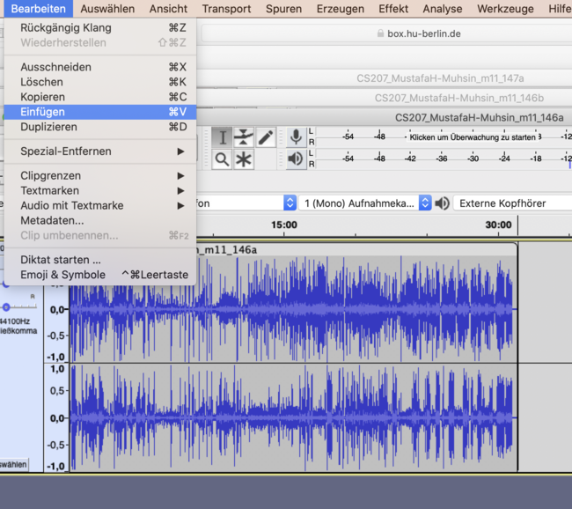

* insert the audio you copied before:
* *[bearbeiten] > [einfügen] [cmd-V]*

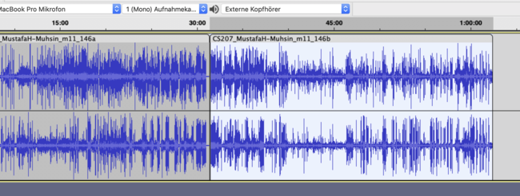

* now second audio should appear after first audio.
* repeat for every audio which is to be added (e.g. 3rd, 4th audio)

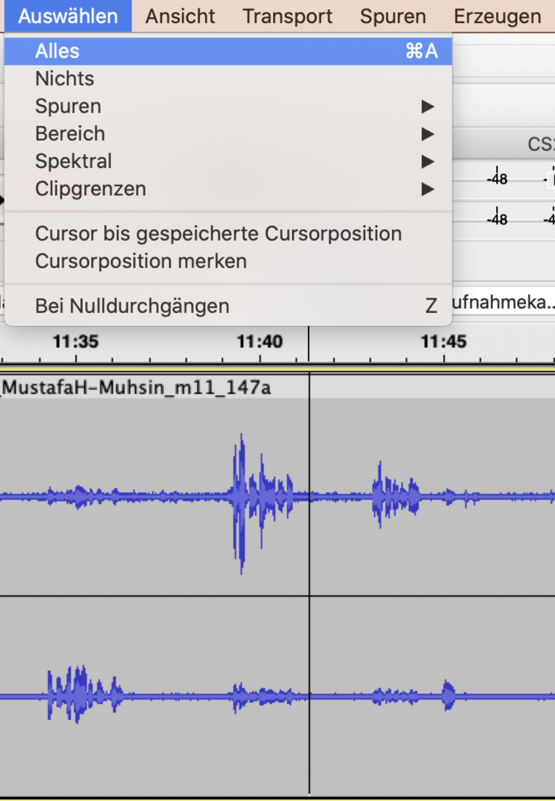

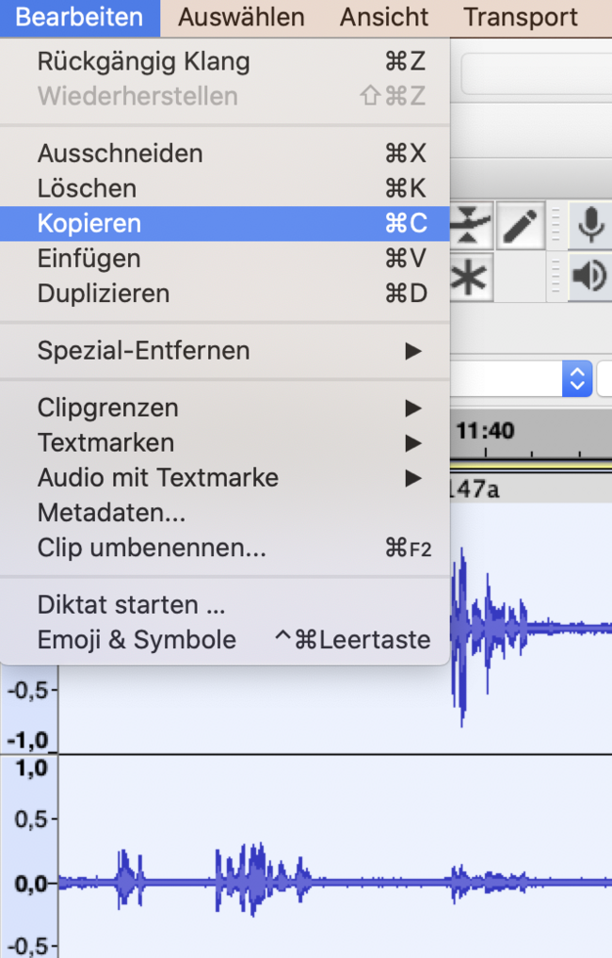

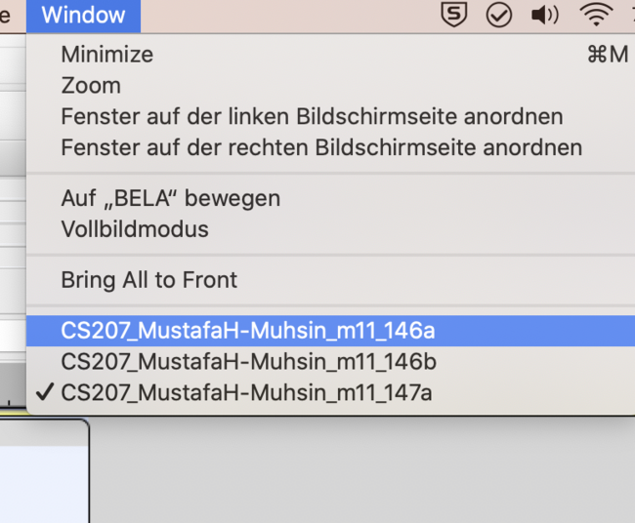

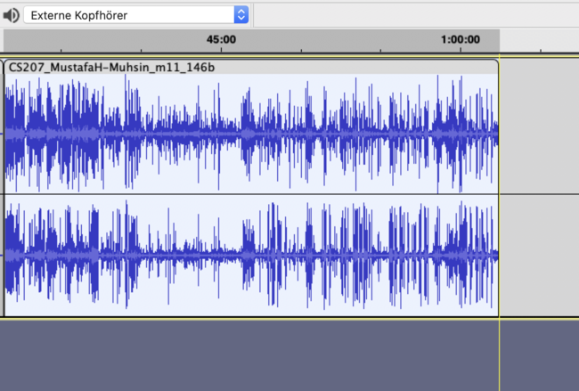

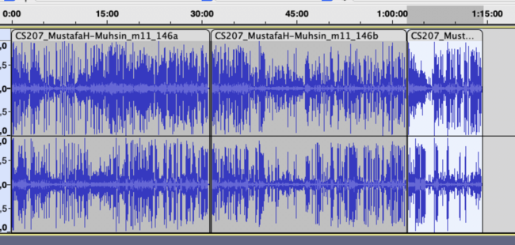

## export mp3

* select complete wave
* eport audio to file:
* *[datei]>[exportieren]>[als mp3 exportieren]*
* choose filename (renamed kid!) according to scheme of anonymised & combined
* choose *constant bitrate* for (export bitrate) at 128kbps (its more compressed then to lesser size)
* upload to HU box anonymised, combined.

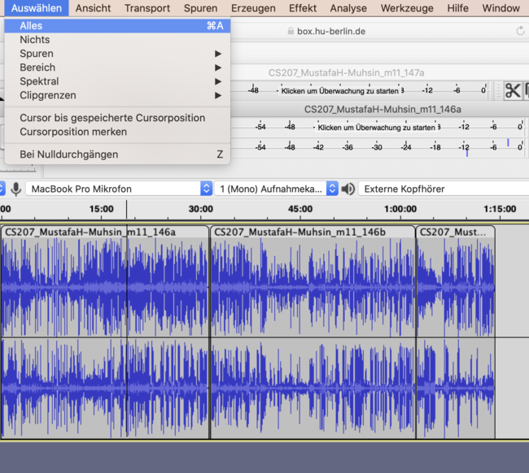

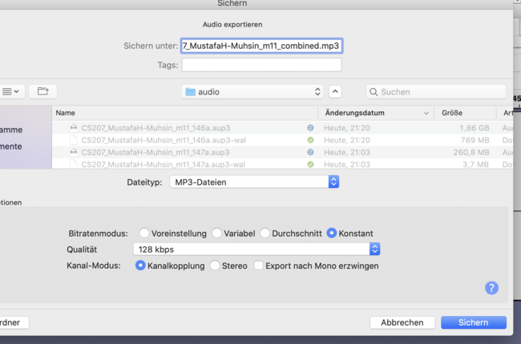

# SES Database

open the database *SES_database_by_tokens.xlsx* in excel or numbers (the database is about 26MByte, on a Mac choose rather Excel, the processing will be faster than in Numbers).  
in general you would prefer e.g. [OpenRefine](https://openrefine.org/docs/manual/installing) instead of excel or numbers for best working with the table.

to filter the table rows for specific tokens, speakers etc:

* open *Daten > Filter*
* click the dropdown arrow in the column you want to filter in, e.g. p_speaker
* deselect the „select all“ button (click on it; by default its selected with a häkchen)
  + now there should be no häkchen in any square/button
* select e.g. the speaker you want to filter for / häkchen setzen
* apply filter
* you can apply several filters at once to limit concordance to language of interview or age or whatever limitation you want
* if you want to filter in the token column, you can put in/search for a free text token and then select what matches your search
* if you want to turn filters off you have to be again in the dropdown filter option of the column and remove the filter there, > *filter entfernen*

## columns explained

|  |  |  |
| --- | --- | --- |
| column | explanation | example |
| p_interview | transcript | GCA |
| p_speaker | speaker | #GCA |
| p_token | token | Mach |
| p_lemma_SkE | sketch engine lemma | machen-v |
| p_lemma | only the lemma | machen |
| p_turn | turn, sentence | #GCA : 43 Mach ich die Arbeit die Schule c_NPV . |
| p_turn_preceding | the preceding turn | #INT : 42 ( activities_after_school ) was machst du nach der Schule , wenn du nicht hier bist ? |
| p_transcriptLine | transcript line of the token | 43 |
| m_feature_eval | empty evaluation column for your researches. you can use this as a selector for finding by turning it TRUE or FALSE | FALSCH |
| m_free_col | empty evaluation column for your researches. you can use this as a selector for finding by turning it TRUE or FALSE | 0 |
| t_tag_SkE | full german RFTag. the following columns seperate this tag into the single items | VIMP.Full.2.Sg |
| t_PoS_ok | selector to switch if the tag is correct | 1 |
| t_PoS | PartOfSpeech | VIMP |
| t_category | NA | Full |
| t_funct | NA | - |
| t_case | NA | - |
| t_pers | NA | 2 |
| t_num | NA | Sg |
| t_gender | NA | - |
| t_tense | NA | - |
| t_mode | NA | - |
| part_L1 | participant L1 | G |
| part_sex | participant sex | f |
| part_age | participant age | 8 |
| part_CoB | participant contry of birth | Greece |
| part_YiG | participant years in germany | 0.5 |
| part_YoSH | particiant years of school in heritage country | 0 |
| part_LPM | participant language proficiency mother | kann deutsch |
| part_LPF | participant language proficiency father | kann deutsch |
| part_LUM | participant language use mother | greek |
| part_LUF | participant language use father | greek |
| part_LUS | participant language use siblings | greek |
| part_LUFR | participant language use friends | N.A. |
| c_NSM | nonstandard semantics | 0 |
| c_PAU | pause | 0 |
| c_NPV | nonstandard possessive | 1 |
| c_NNS | nonstandard not specified | 0 |
| c_NPR | nonstandard preposition | 0 |
| c_NAG | nonstandard agreement | 0 |
| c_0MD | zero modal | 0 |
| c_0SU | zero subject | 0 |
| c_NWO | nonstandard word order | 0 |
| c_0OB | zero object | 0 |
| c_0PR | zero preposition | 0 |
| c_COM | comment | 0 |
| c_NCM | nonstandard comparison | 0 |
| c_0AR | zero article | 0 |
| c_NVP | nonstandard VP | 0 |
| c_0VP | zero VP | 0 |
| c_NGN | nonstandard gender | 0 |
| c_0AU | zero auxiliary | 0 |
| c_0CP | zero copula | 0 |
| c_NEX | nonstandard existential | 0 |
| c_NRL | nonstandard relative | 0 |
| c_NAR | nonstandard article | 0 |
| c_NMD | nonstandard modal | 0 |
| c_0PT | zero predicate | 0 |
| c_NPE | nonstandard person | 0 |
| c_0RF | zero reflexive | 0 |
| c_NIO | nonstandard i.o. | 0 |
| c_NPS | nonstandard person | 0 |
| c_0PN | zero plural/numeral | 0 |
| c_NPO | nonstandard pronoun | 0 |
| c_0RL | zero relative | 0 |
| c_0EX | zero existential | 0 |
| c_NNN | nonstandard not specified | 0 |
| c_NCP | nonstandard copula | 0 |
| c_0RP | zero reflexive pronoun | 0 |
| c_0PD | zero predicate | 0 |
| c_NVC | nonstandard vocab | 0 |
| c_NEA | nonstandard extra article | 0 |
| c_NCN | nonstandard conditional | 0 |

## summary

as you see in above table, theres a lot of possible filtering options working with the SES database.  
you can do simple queries for token, lemma or PoS tag or refine your query applying filters to metadata or coded features as well.

# Sketch Engine

this is a short tutorial of how to import texts to [Sketch Engine](https://auth.sketchengine.eu/#login) to create a corpus of your own. you can then do researches in this corpus via the SketchEngine exploration tools.

## log in to Sketch Engine

open the Sketch Engine login page via: <https://auth.sketchengine.eu/#login> and choose your affiliated institution. you can also create your own account or log in via google.

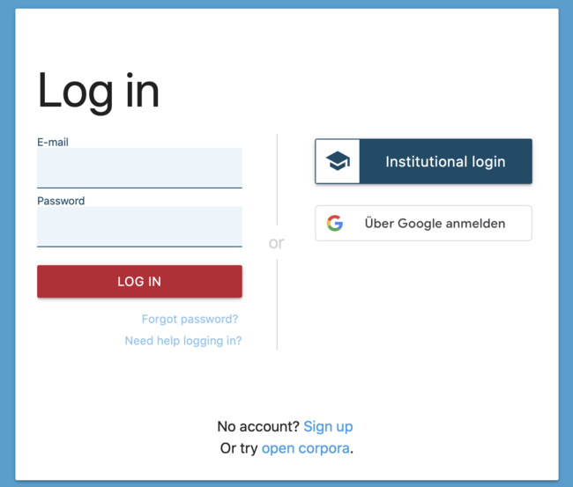

login1

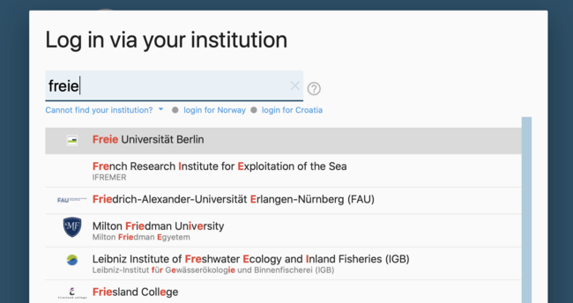

login2

## create new corpus

1. in the dashboard click >manage corpus<

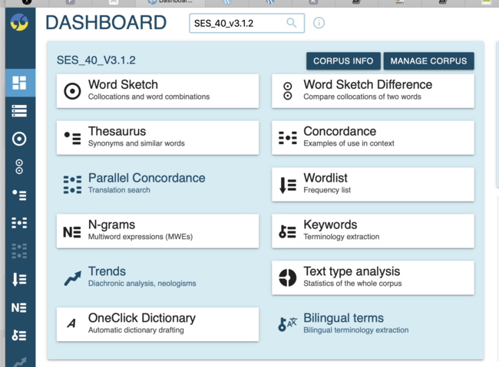

1. select >new corpus<

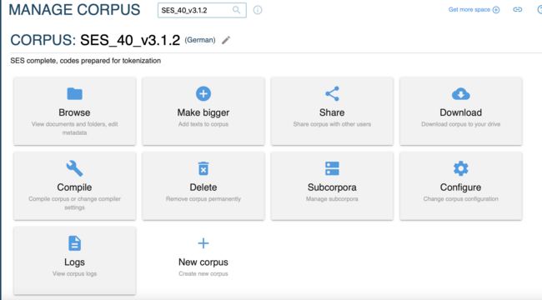

## import texts

1. give your corpus a name and provide a description. choose the language of your corpus:

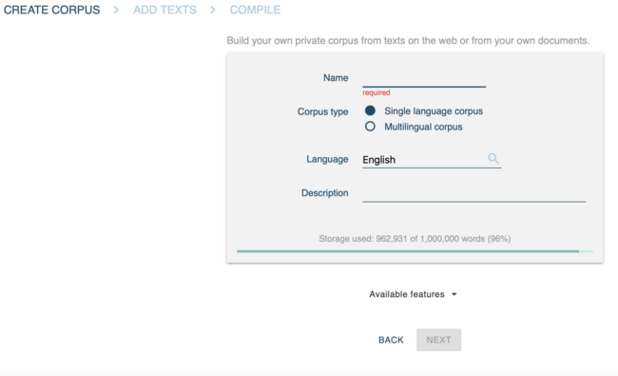

1. import your texts. these can be single files of the supported format (.txt, .pdf. etc.) or a .zip file of these. if you want to import the SES transcripts, choose the version without header for sketchengine that you will find in the HU-BOX.

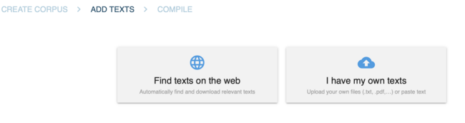

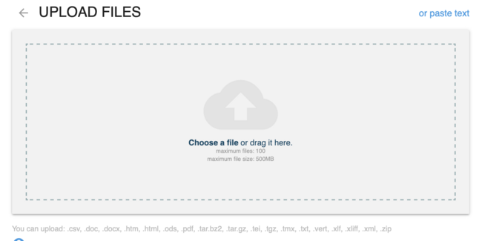

1. the upload takes some time. if the texts have been uploaded successfully, you see your upload summary and wordcount.

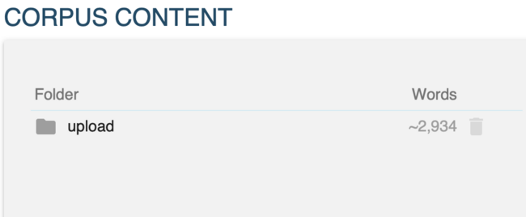

## compile corpus

start the compilation of your corpus. this will tag the texts with PartOfSpeech-tags and lemmatize the words. more information on the used (for german) tagset you find [here](https://www.sketchengine.eu/German-rftagger-part-of-speech-tagset/).

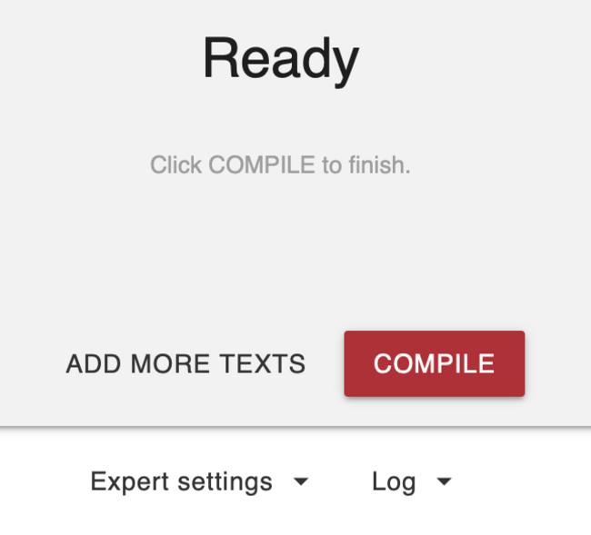

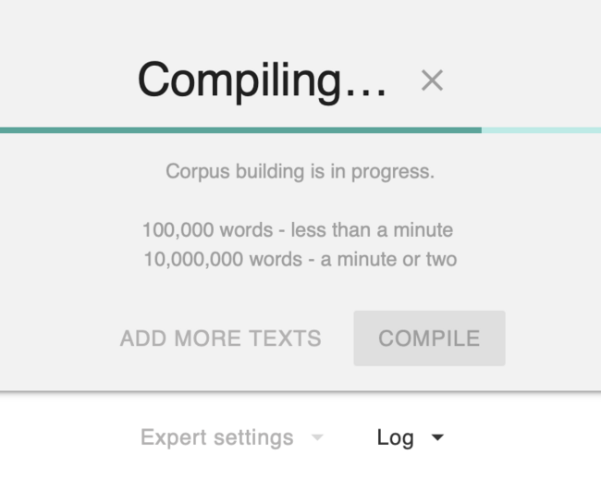

your corpus is now ready to be explored. find all information to the query language and further guides in the [Sketch Engine Help](https://www.sketchengine.eu/German-rftagger-part-of-speech-tagset/)

# ANNIS framework

find your way through: <https://corpus-tools.org/annis/>, install ANNIS on your system and try to import the zipped ANNIS SES corpus you find in the HU-box.

> folder: sketch engine Work, namescheme of latest zip: [datestamp]_SES_annis_tagged_corpus.zip

## SES sample procedure to create ANNIS corpus

**the following is just for documentation of the process; you wont have to follow these steps, just follow above instructions to install ANNIS on your system and import the zipped corpus.**

* upload files in HU box folder version without header for SketchEngine upload to SketchEngine > *create new corpus*
* *expert compiler settings* > adapt docscheme to > sesCPT
  + with that done you can already explore the SES corpus in the SketchEngine GUI using the built in CQL (corpus query language) commands.
* download corpus (vertical)
  + corpus is now a database of token, PoS, lemma; tagged according to the GermanRF tagset[1] used by SketchEngine
* process database in: [conc-essai.R](https://github.com/esteeschwarz/HU-LX/blob/main/scripts/conc_essai.R)
  + splits PoS tag (scheme: x.x.x.x.x) into seperate columns defining classes of PoS tags
  + writes single .xlsx files for each kid into folder
  + ANNIS preprocessing:
    - [pepper](https://corpus-tools.org/pepper/): xls > treetagger format from .xlsx files folder. [parameter file](https://github.com/esteeschwarz/HU-LX/blob/main/scripts/r-conxl1.pepper)
    - pepper: treetagger > annis graph format from treetagger files folder. [parameter file](https://github.com/esteeschwarz/HU-LX/blob/main/scripts/r-conxl2.pepper)
    - zip annis graph files
* upload annis.zip to ANNIS localhost server

## ANNIS ready to use installation:

please find here: link follows an ANNIS server installation with the SES corpus ready to use. (! 20230904: the link is not yet freely available, use the link shared in moodle if you dont want to use your own local installation !)

# BERLANGDEV

this part will include workflow description of how to upload content to BERLANGDEV and edit metadata.

## short overview of basic workflow:

* login to [BERLANGDEV](https://rs.cms.hu-berlin.de/berlangdev/pages/collection_manage.php)
* click <upload>
* upload dialogue opens.

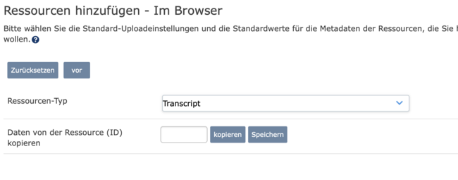

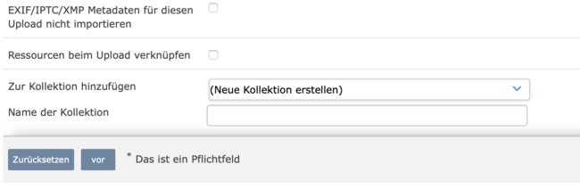

* you can skip everything except:
  + top > ressourcentyp: choose type of ressource to upload
  + bottom > zur kollektion hinzufügen: choose collection to which to upload resource
  + you can upload several resources at once and edit metadata afterwards
* when the resource appears in the collection view, click on it (opens it)
* go to <edit metadata/metadaten bearbeiten>

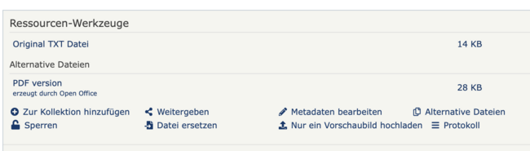

* add ID of related resource to insert metadata (e.g. any ID of another resource of the same kid)

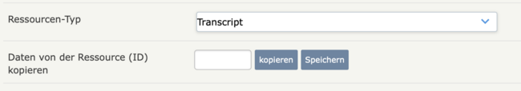

* IMPORTANT: make sure to edit the metadata (which contains now just a copy of the other resource from where you copied it) and adapt it to your resource. theres few entries which you will have to change tout cas:

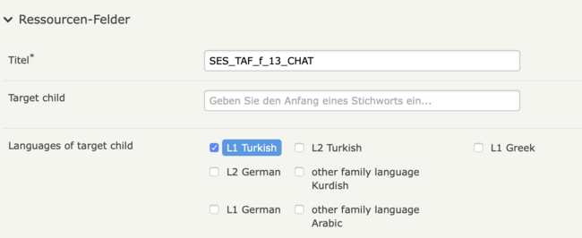

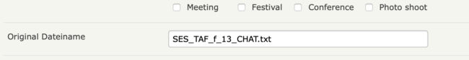

* check for: interview language, which my differ depending from which resource you copied the metadata.
* make sure filename points to your resource and name depicts the correct resource in the overview.
* if you had uploaded several trials of the same resource which will have lead to an automatically generated number at the end of the description, please remove any earlier of your upload trials and change the displayname of the final resource according to the scheme, without any trailing numbers or additions may derive from your computers filesystem.
* finally: connect all related resource, i.e. add all resource IDs of the same kid into the bottom field <verwandte resourcen>

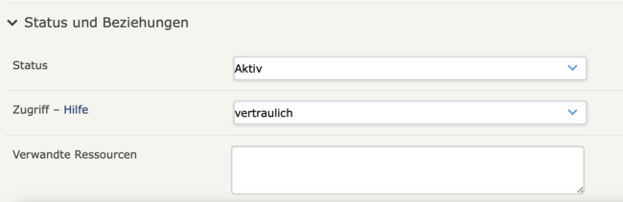

# SES: BERLANGDEV media status

|  |  |  |  |  |  |
| --- | --- | --- | --- | --- | --- |
| id | child | CHAT | sanscodes | pdf | audio |
| 1 | GCA | 1 | 1 | 1 | 1 |
| 2 | GCB | 1 | 1 | 1 | 1 |
| 3 | GCC | 1 | 1 | 1 | 1 |
| 4 | GCD | 1 | 1 | 1 | 1 |
| 5 | GCE | 1 | 1 | 1 | 1 |
| 6 | GCF | 1 | 1 | 1 | 1 |
| 7 | GCG | 1 | 1 | 1 | 1 |
| 8 | GDA | 1 | 1 | 1 | 1 |
| 9 | GDB | 1 | 1 | 1 | 0 |
| 10 | GDC | 1 | 1 | 1 | 1 |
| 11 | GDD | 1 | 1 | 1 | 1 |
| 12 | GDE | 1 | 1 | 1 | 0 |
| 13 | GDF | 1 | 1 | 1 | 1 |
| 14 | TAA | 1 | 1 | 1 | 1 |
| 15 | TAB | 1 | 1 | 1 | 0 |
| 16 | TAC | 1 | 1 | 1 | 0 |
| 17 | TAD | 1 | 1 | 1 | 1 |
| 18 | TAE | 1 | 1 | 1 | 1 |
| 19 | TAF | 1 | 1 | 1 | 1 |
| 20 | TAG | 1 | 1 | 1 | 1 |
| 21 | TAH | 1 | 1 | 1 | 1 |
| 22 | TAI | 1 | 1 | 1 | 1 |
| 23 | TBB | 1 | 1 | 1 | 1 |
| 24 | TBC | 1 | 1 | 1 | 1 |
| 25 | TBD | 1 | 1 | 1 | 1 |
| 26 | TBE | 1 | 1 | 1 | 1 |
| 27 | TBF | 1 | 1 | 1 | 1 |
| 28 | TBG | 1 | 1 | 1 | 1 |
| 29 | TBH | 1 | 1 | 1 | 1 |
| 30 | TBI | 1 | 1 | 1 | 1 |
| 31 | TBK | 1 | 1 | 1 | 1 |
| 32 | TBL | 1 | 1 | 1 | 1 |
| 33 | TBM | 1 | 1 | 1 | 1 |
| 34 | TBN | 1 | 1 | 1 | 1 |
| 35 | TBO | 1 | 1 | 1 | 1 |
| 36 | TBP | 1 | 1 | 1 | 1 |
| 37 | TBQ | 1 | 1 | 1 | 1 |
| 38 | TBR | 1 | 1 | 1 | 1 |
| 39 | TBS | 1 | 1 | 1 | 1 |
| 40 | TBT | 1 | 1 | 1 | 1 |
| 41 | TBU | 1 | 1 | 1 | 1 |
| 42 | TBV | 1 | 1 | 1 | 1 |

# SES class findings

brief overview of student findings exploring the corpus

## 001

|  |  |  |  |  |  |  |  |
| --- | --- | --- | --- | --- | --- | --- | --- |
| Student | Child.Code | Age | Prepositions | Articles | Conjunctions | Paraphrase.with.verb | Hesitation.phenomena..Pauses..repeated.articles |
| Griechische Kinder | NA | NA | NA | NA | NA | NA | NA |
| Laura | GCC | 9 | auf: 3, an: 1, in: 7, nach: 1, zu: 7 - zun: 1, hinter:0, neben:0, vor:1 | NA | NA | NA | Viele Pausen, häufiges Zögern |
| NA | GDC | 8 | auf: 12, an:1, in 19 anstatt <im:1>, nach:5, zu:1, hinter:0, neben:0, vor:1 | NA | NA | NA | viele Pausen |
| NA | GCG | 9 | NA | NA | NA | NA | überlegt oft kurz, wenn sie nicht genau weiß, was sie zunächst sagen wird |
| NA | GDD | 9 | NA | NA | NA | NA | NA |
| Türkische Kinder | NA | NA | NA | NA | NA | NA | NA |
| Laura | TAC | 12 | auf: 16, an: 2, in: 6, nach: 4, zu: 7, hinter: 0, neben: 2, vor: 1 | NA | NA | NA | wenig Pausen oder Zögern |
| NA | TBF | 12 | NA | NA | NA | NA | NA |
| NA | TAI | 13 | auf: 8, an: 1, in: 12, nach: 5, zu: 3, hinter: 1, neben: 3, vor: 1 | NA | NA | NA | Viele Pausen, häufiges Zögern |
| NA | TBB | 14 | NA | NA | NA | NA | NA |

## 002

|  |  |  |  |  |  |  |  |
| --- | --- | --- | --- | --- | --- | --- | --- |
| Student | Child.Code | Age | Prepositions | Noticing | Self.correction..content.or.form. | Interviewer | More.information |
| Griechische Kinder | NA | NA | NA | NA | NA | NA | NA |
| Katharina | GDA | 11 | NA | 0016 bis 0022 (answers INT not transcripted)//GDA: Hier, das Maedchen und ein Jung basteln einen Schneemann. Das Maedchen macht ein Mohrruebe fuer Nase. Und hier gibt sie…@ ’ne…@ ’ne Stock 90 obj i.o.. //INT: was ist das? //GDA: Das hier? hm //INT: was macht man damit? //GDA: Machen sauber. //INT: Genau, n Besen./[später:] und nicht den Besen/–>Bedeutungsverhandlung: gemeinsam Semantik umschreiben und erfassen; dann Vorschlag, der aufgegriffen wird/ | 0194 [Drachen] wenn es ganz gut Luft ist, Luft gib’s, dann… /0237 Hier fragt ein Frau…@ den Schna- Schaffner wo geht da, der Zug | lacht viel, macht Späße, fragt freundlich nach, stimmt, genau/Recasts/0096 (answer not transcripted) Er faellt sich um. Hmh, fällt runter. (Übergeneralisierung reflexive Verben)/0104 (answer not transcripted) [der Junge] fangt. Ja, fängt. /0181 (answer not transcripted) Soll ich sagen, wohin sie gehört? Ja, dann ist da noch irgendwas, was dazu gehört./0182 (answer not transcripted) Hier sind so Kristall. Eis. Ja genau, Eis. Eiskristalle | NA |
| Türkische Kinder | NA | NA | NA | NA | NA | NA | NA |
| Katharina | TAF | 13 | NA | Zeile 0059 (Chat file) Kopf/–> Noticing, Pause + direkter Vorschlag – lernt direkt etwas neues/0091 (Chat) Besen/–> Vorschlag, der direkt übernommen wird./0103 0104 (Chat) Mohrrübe/ | Sie setzt sich im einen Wagen und der Maedchen zieht sie- zieht er. (0068)/Ja, wenn du kein Fahrer- Fahrkarte hast, dann musst du wieder aussteigen. (0163)/weil, er traegt viel schwerer und er traegt (…) langs- ne bisschen leichter (0131) /da finden die- da find der Junge sein Vater und Mutter (0179)/–> Umstrukturierung Syntax auch für L1 typisch | Interviewer sagt v.a. ok, gut, hmh, prima, alles ist erlaubt, lacht, ermutigt bei langen Pausen, weiterzumachen//Nachfrage Zeile 0038 (Chat) Irrenhaus//Recast 0146 (answer from INT not transcipted)//der Apfel gehoert die Aepfeln. Und warum gehören die beiden zusammen? | Viele und lange, ungefüllte Pausen |
| NA | TBV | 14 | NA | NA | NA | NA | NA |
| NA | TBE | 13 | NA | NA | NA | NA | NA |
| NA | TBF | 12 | NA | NA | NA | NA | NA |
| NA | TBM | 13 | NA | NA | NA | NA | NA |
| NA | TBN | 14 | NA | NA | NA | NA | NA |

## 003

|  |  |  |  |  |  |  |  |
| --- | --- | --- | --- | --- | --- | --- | --- |
| Student | Child.Code | Age | Prepositions | Articles | Conjunctions | Hesitation.phenomena..Pauses..repeated.articles | Self.correction..content.or.form. |
| Griechische Kinder | NA | NA | NA | NA | NA | NA | NA |
| Miriam | GCA | 8 | auf: 3/an: 1 -> am: 1/in: 31/nach: 4/zu: 3/hinter: 1/neben:/vor: 0 | Reduced forms ///n: 1 -> ein/einen | und: 95/dann: 11/danach: 0/weil: 1 | Viele Pausen, häufiges Zögern | Wenig Selbstkorrekturen |
| NA | GCE | 11 | auf: 0/an: 0/in: 0/nach: 0/zu: 0/hinter: 0/neben: 0/vor: 0 | Reduced forms /// | und: 180/dann: 25/danach: 2/weil: 3 | Wenig Pausen oder Zögern | Mehr Selbstkorrekturen |
| NA | GDE | 10 | auf: 31/an: 0/in: 49 -> inzu: 1/nach: 5/zu: 26 -> inzu: 1/hinter: 3/neben: 2/vor: 3 | Reduced forms ///n: 4 -> ein/einen//ne: 5 -> eine//s | und: 57/dann: 13/danach: 1/weil: 9 | Seit 10 Jahren in Deutschland/Keine Audio-Datei | NA |
| NA | GDF | 11 | auf: 10/an: 0/in: 25/nach: 6/zu: 15/hinter: 2/neben: 2/vor: 2 | Reduced forms / | Und/Und dann/danach/weil | Wenig Pausen oder Zögern | Bewusste Selbstkorrekturen |
| Türkische Kinder | NA | NA | NA | NA | NA | NA | NA |
| Miriam | TAA | 13 | auf: 16/an: 2/in: 6/nach: 4/zu: 7/hinter: 0/neben: 2/vor: 1 | Reduced forms / | Und/Und dann/danach/weil | Wenig Pausen oder Zögern | Inhaltliche Selbstkorrekturen, weniger grammatikalisch |
| NA | TAD | 14 | auf: 2 -> aufm: 1/an: 0/in: 5 -> inne: 1/nach: 2/zu: 6/hinter: 1/neben: 2/vor: 0 | Reduced forms / | Und/Und dann/danach/weil | Viele Pausen, häufiges Zögern | Wenig Selbstkorrekturen |
| NA | TBC | 14 | auf: 14/an: 6/in: 9/nach: 2/zu: 16/hinter: 3 -> hinterher: 1/neben: 4/vor: 0 | Reduced forms / | Und/Und dann/danach/weil | Viele Pausen, häufiges Zögern | Wenig Selbstkorrekturen |
| NA | TBD | 13 | auf: 14/an: 0/in: 18/nach: 6/zu: 7/hinter: 0/neben: 1 -> daneben: 1/vor: 2 | Reduced forms / | Und/Und dann/danach/weil | Wenig Pausen oder Zögern | Wenig Selbstkorrekturen |
| Carol | test-ok | NA | NA | NA | NA | NA | NA |

## principle of accountability

roughly: the number of occurences of one (coded nonstandard) feature over the number of total instances of the feature (including standard + nonstandard realisations).[2], e.g.:

|  |  |  |  |  |
| --- | --- | --- | --- | --- |
| token | instances | standard | nonstandard | normalised |
| schnee | 54 | 33 | 21 | 38.8888889 |
|  |  |  |  |  |
|  | all | coded “FALSCH” | coded “1” (feature = TRUE) | percent (D2/B2*100) |

workflow:

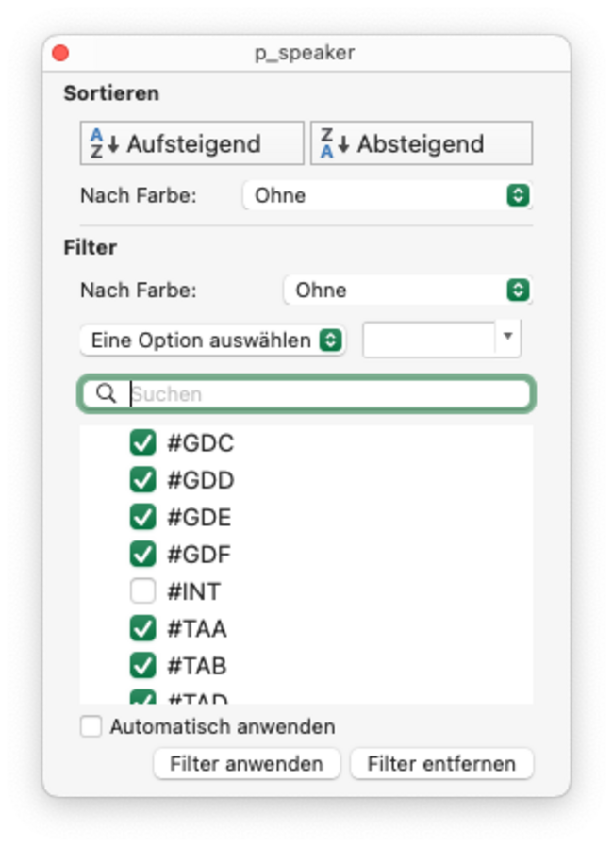

filter out #INT speaker

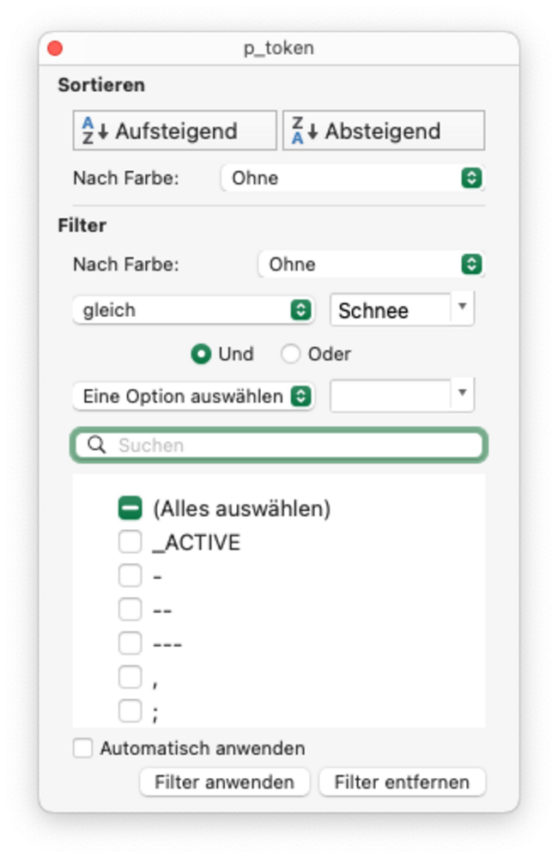

filter after token schnee

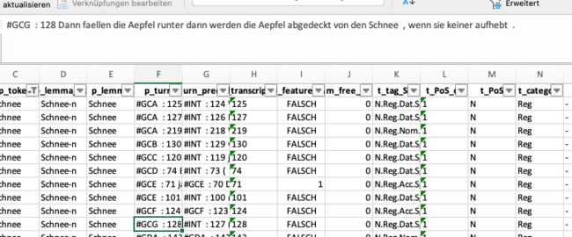

analyse turn (manually)

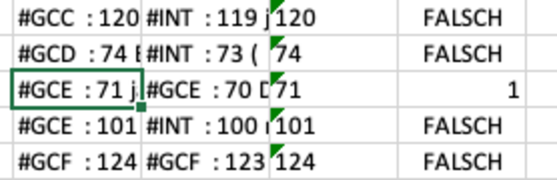

set evaluation column to 1=TRUE if nonstandard occurence (context)

1. filter out #INT speaker
2. filter after token [schnee]
3. analyse turn and define wether standard or nonstandard feature
4. set evaluation column to 1=TRUE for nonstandard occurences
5. sum up number of total instances
6. sum up number of positives (nonstandard realisation)
7. compute number of negatives (standard)
8. compute percentage

## SES distribution analysis

the following is the output table of the multivariate analysis of a frequency table of all feature codes over all target childs.  
the frequency table was exported from an ANNIS installation of the SES corpus. the query for getting the proper results is:  
codetag = /c_.*/ & int = /T.*|G.*/ & #1 . #2 this outputs all occuring codes over the transcripts and associates them to the speaker, either T=any turkish or G=any greek. with that you get a frequency table looking like this (exerpt):

|  |  |  |
| --- | --- | --- |
| featurecode | child | count |
| NPR | GCA | 16 |
| COM | TBR | 16 |
| COM | TAA | 15 |
| 0AR | TBL | 14 |
| NPR | TBT | 14 |
| 0AR | GCB | 14 |
| COM | TBL | 14 |
| 0AR | GDA | 13 |
| COM | TBM | 13 |
| NNS | TBQ | 13 |
| 0AR | TBS | 13 |
| COM | GCA | 13 |
| NPR | TBU | 12 |
| NPR | GCC | 12 |
| 0AR | TBT | 12 |
| COM | TBU | 12 |
| 0AR | TBU | 11 |
| NNS | GCB | 11 |

visualised: 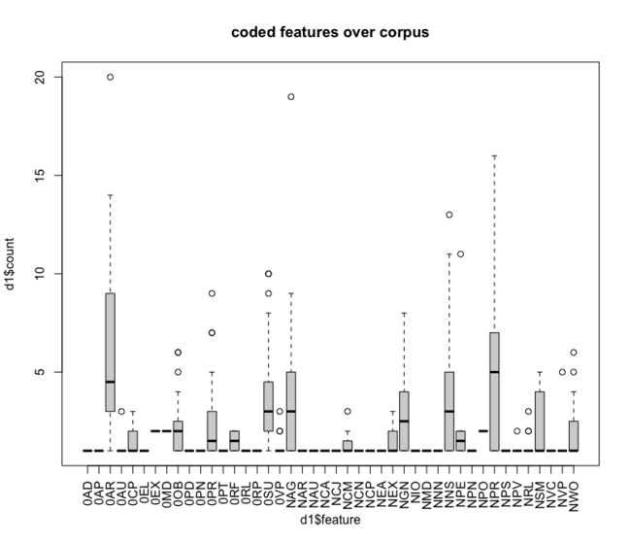

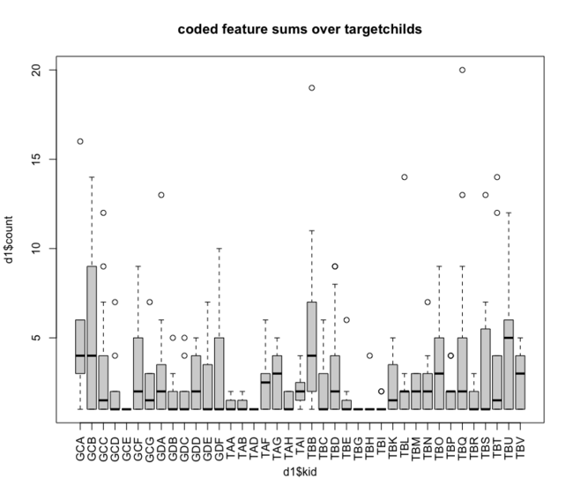

### small significance testing:

script source: <https://github.com/esteeschwarz/HU-LX/blob/main/scripts/distribution-analysis.R>

the applied lmer (linear mixed effects regression model) [3] formula is:  
count ~ feature + (1 | L1)  
in words: *we posited a main effect of feature and random effects of L1*. with this assumption a significance of p < 0.05 was tested at 0AR (zero article), i.e. the coding of this feature (here) depends significant on the L1 use of the target child. **IMPORTANT:** this does not allow general statements about the relation of 0AR feature and L1 since the transcript corpus was not coded/annotated until every instance of each feature.

### lmer coefficients

|  |  |  |  |  |  |  |  |
| --- | --- | --- | --- | --- | --- | --- | --- |
|  | Estimate | Std. Error | df | t value | Pr (>t) |  |  |
| feature0AR | 5,324 | 2,778 | 333 | 1,916 | 0,056 |  |  |
| featureNPR | 4,286 | 2,786 | 333 | 1,538 | 0,125 |  |  |
| featureNAG | 3,353 | 2,817 | 333 | 1,19 | 0,235 |  |  |
| featureNNS | 2,8 | 2,792 | 333 | 1,003 | 0,317 |  |  |
| feature0SU | 2,571 | 2,777 | 333 | 0,926 | 0,355 |  |  |
| featureNGN | 1,893 | 2,786 | 333 | 0,679 | 0,497 |  |  |
| featureNPE | 2 | 2,957 | 333 | 0,676 | 0,499 |  |  |
| feature0PR | 1,682 | 2,799 | 333 | 0,601 | 0,548 |  |  |
| feature0OB | 1,261 | 2,797 | 333 | 0,451 | 0,652 |  |  |
| featureNSM | 1,167 | 2,794 | 333 | 0,418 | 0,677 |  |  |
| featureNWO | 1,067 | 2,828 | 333 | 0,377 | 0,706 |  |  |
| (Intercept) | 1 | 2,738 | 333 | 0,365 | 0,715 |  |  |
| feature0EX | 1 | 3,353 | 333 | 0,298 | 0,766 |  |  |
| feature0MD | 1 | 3,872 | 333 | 0,258 | 0,796 |  |  |
| featureNPO | 1 | 3,872 | 333 | 0,258 | 0,796 |  |  |
| featureNVP | 0,667 | 2,957 | 333 | 0,225 | 0,822 |  |  |
| featureNEX | 0,6 | 2,999 | 333 | 0,2 | 0,842 |  |  |
| feature0RF | 0,5 | 3,353 | 333 | 0,149 | 0,882 |  |  |
| featureNCM | 0,429 | 2,927 | 333 | 0,146 | 0,884 |  |  |
| feature0CP | 0,375 | 2,822 | 333 | 0,133 | 0,894 |  |  |
| feature0AU | 0,333 | 2,957 | 333 | 0,113 | 0,91 |  |  |
| feature0VP | 0,308 | 2,841 | 333 | 0,108 | 0,914 |  |  |
| featureNRL | 0,267 | 2,828 | 333 | 0,094 | 0,925 |  |  |
| featureNPV | 0,091 | 2,86 | 333 | 0,032 | 0,975 |  |  |
| feature0AP | 0 | 3,872 | 333 | 0 | 1 |  |  |
| feature0EL | 0 | 3,872 | 333 | 0 | 1 |  |  |
| feature0PD | 0 | 3,872 | 333 | 0 | 1 |  |  |
| feature0PN | 0 | 3,061 | 333 | 0 | 1 |  |  |
| feature0PT | 0 | 3,872 | 333 | 0 | 1 |  |  |
| feature0RL | 0 | 3,872 | 333 | 0 | 1 |  |  |
| feature0RP | 0 | 3,872 | 333 | 0 | 1 |  |  |
| featureNAR | 0 | 2,927 | 333 | 0 | 1 |  |  |
| featureNAU | 0 | 3,872 | 333 | 0 | 1 |  |  |
| featureNCA | 0 | 3,872 | 333 | 0 | 1 |  |  |
| featureNCJ | 0 | 3,872 | 333 | 0 | 1 |  |  |
| featureNCN | 0 | 3,872 | 333 | 0 | 1 |  |  |
| featureNCP | 0 | 3,872 | 333 | 0 | 1 |  |  |
| featureNEA | 0 | 3,872 | 333 | 0 | 1 |  |  |
| featureNIO | 0 | 3,872 | 333 | 0 | 1 |  |  |
| featureNMD | 0 | 3,872 | 333 | 0 | 1 |  |  |
| featureNNN | 0 | 3,872 | 333 | 0 | 1 |  |  |
| featureNPN | 0 | 3,872 | 333 | 0 | 1 |  |  |
| featureNPS | 0 | 2,957 | 333 | 0 | 1 |  |  |
| featureNVC | 0 | 3,872 | 333 | 0 | 1 |  |  |

# GLOSSARY/ANNEX: on a funny note

## to avoid further confusion

some explanation to terms used maybe outdated and other stuff useful to know:

|  |  |  |
| --- | --- | --- |
| term used | german | english |
| leerzeichen, space, spacebar | whitespace |  |
| return, enter, CR | senden, bestätigen, ausführen, zurück |  |
| CMD, command | apple: befehlstaste |  |
| CTRL, control, steuerung, STRG | apple: steuerungstaste |  |
| ALT | apple: wahltaste | apple: option |
| SHIFT | apple: umschalten wtf. |  |
| backspace | ? |  |
| delete | ? |  |
| extension |  | the part of the filename after the dot (.) which enables your operating system to recognize the fileformat and choose the appropriate application to open the file with. e.g.: .mp3 for music, .jpg for pictures, .txt for plaint text files, .docx for word documents. (the extension doesnt really matter, you can open any file from within any application as well with the \<open\> dialogue of the application, but to enable opening a file by just clicking at it, it has to have an extension to signal the system which app to choose. |
| segmentation |  | in the partitur editor you can segment a transcript/text into several parts. the decision of what is part of a segment depends on the questions you have to the text or how you want to annotate it. segmentation per token allows for token limited annotation, segmentation per clause or sentence for wider range annotation. a segment has to be finished with a whitespace, i.e. the last character of a segment has to be a leerzeichen/whitespace/empty character. |
| regex, regular expressions | reguläre ausdrücke | [info](https://ahkde.github.io/docs/v1/misc/RegEx-QuickRef.htm) / [learn/try out regular expressions](https://regexr.com) |

to dive deeper into the sujet: <https://de.wikipedia.org/wiki/Tastenkombination>

1. <https://www.sketchengine.eu/German-rftagger-part-of-speech-tagset/>
2. Labov, William. Sociolinguistic Patterns / William Labov. 1. publ. Oxford: Blackwell, 1972. Print.
3. Bates u. a., „Fitting Linear Mixed-Effects Models Using lme4“. 2015. [doi: 10.18637/jss.v067.i01](10.18637/jss.v067.i01)